

**US Army Corps of Engineers**

**Afghanistan Engineer District**

AED Design Requirements:

Well Pumps & Well Design

Various Locations, Afghanistan

July 2012, Version 2.1

**TABLE OF CONTENTS**

AED DESIGN REQUIREMENTS FOR

WELL PUMPS & WELL DESIGN VARIOUS LOCATIONS, AFGHANISTAN

**Contents**

**1. GENERAL ........................................................................................................................1**

**2. WELL CONSTRUCTION SEQUENCING ..................................................................2**

**3. REQUIRED REPORTING.............................................................................................2**

**3.1 Well Test and Construction Plan ....................................................................................3**

**3.2 Water Quality Testing and Reporting............................................................................3**

**3.3 Test Results and Permanent Well Design Report .........................................................3**

**3.4 As-Built Drawings ............................................................................................................4**

**4. SELECT WELL SITE.....................................................................................................4**

**5. DRILL WELL BOREHOLE ..........................................................................................5**

**6. PRELIMINARY WELL TESTING...............................................................................6**

**6.1 Pumping Tests ..................................................................................................................6**

**6.2 Water Quality Testing .....................................................................................................7**

**7. PROPOSE FINAL WELL DESIGN ..............................................................................8**

**7.1 Well Casing .....................................................................................................................10**

**7.1.1 Surface Casing .........................................................................................................10**

**7.1.2 Well Casing Diameter. ............................................................................................11**

**7.2 Well and Casing Depth. .................................................................................................13**

**7.3 Casing Material. .............................................................................................................13**

**7.4 Well screens ...................................................................................................................13**

**7.5 Filter Packing..................................................................................................................16**

**7.6 Grouting and Sealing .....................................................................................................18**

**7.6.1 Bentonite Seal...........................................................................................................18**

**7.6.2 Neat Cement/Grout .................................................................................................18**

**7.6.3 Cement Surface Seal................................................................................................18**

**7.7 Accessibility.....................................................................................................................19**

**7.8 Details Relating to Water Quality.................................................................................19**

**7.8.1 Location ....................................................................................................................19**

**7.8.2 Concrete Cover. .......................................................................................................19**

i

**7.8.3 Casing Height ............................................................................................................19**

**7.8.4 Well House................................................................................................................19**

**7.8.5 Security ......................................................................................................................20**

**7.9 Well Pumps .....................................................................................................................20**

**7.9.1 Pump Type ...............................................................................................................20**

**7.9.2 Pump Capacity.........................................................................................................22**

**8. RECEIVE AED APPROVAL.......................................................................................23**

**9. CONSTRUCT PERMANENT WELL.........................................................................24**

**10. DEVELOP AND DISINFECT WELL.........................................................................24**

**10.1 Well Development. .......................................................................................................24**

**10.1.1 Well Development Requirements ..........................................................................25**

**10.2 Well Disinfection ..........................................................................................................26**

**11. TEST WELL PERFORMANCE ..................................................................................26**

**12. SUBMIT WELL COMPLETION REPORT ..............................................................27**

**13. MULTI-WELL FIELDS ...............................................................................................27**

**13.1 Radius of Influence Calculations ................................................................................28**

**14. REFERENCES............................................................................................................. 322**

**LIST OF APPENDICES**

**Appendix A – Examples of Unacceptable and Acceptable Well Construction**

**Appendix B – Theoretical Well Screen and Filter Pack Design**

**Appendix C – Well Pump Hydraulic Sizing Example**

**Appendix D – Cited References from Driscoll, *Groundwater and Wells*, 1986**

**Appendix E – Water Well Summary Sheet and Instructions**

**Appendix F – Well Screen and Bentonite Suppliers**

**LIST OF TABLES**

**Table 1. Minimum Distance from Pollution Sources 5**

**Table 2. Water Quality Testing Parameters 8**

**Table 3. Well Diameter vs. Anticipated Yield 12**

**Table 4. Change in Yield for Variation in Well Diameter 12**

**Table 5. Minimum Steel Pipe Casing Wall Thicknesses 13**

**Table 6. Estimated Sand Transport Velocities 15**

**Table 7. Relative Open Screen Space vs. Diameter and Slot Size 15**

**Table 8. ASTM Standard Sieve Sizes 17**

**Table 9. Characteristics of Pumps 21**

**LIST OF FIGURES**

**Figure 1. Diagrammatic Section of Gravel-Packed Well 9**

**Figure 2. Well in Bedrock 10**

**Figure 3. Minimum Effective Open Area vs. Well Yield 16**

**Figure 4. Diagram of Water Table Well 30**

**Figure 5. AED Well Requirements 31**

**1. GENERAL**

This document is available online at <http://www.aed.usace.army.mil/Design.asp>. Its purpose is to provide an overview of the information needed by Contractors to design and construct wells for the Afghanistan Engineering District (AED). Even under the best of conditions, building a successful well requires many scientific disciplines, access to supplies and equipment, experienced personnel, and a bit of luck. Building wells in Afghanistan necessarily requires some unique approaches and simplifications.

The document is organized in the following manner. The main body of the document provides information, concepts and guidelines related to site planning, design processes and construction methods. Appendix A provides information on acceptable and unacceptable construction techniques and materials used on AED projects. Photographs are provided to help Contractors understand what AED will and will not accept during a well construction project. Appendix B contains procedures on well screen and filter pack design when depth-dependent gradation curves are available. Appendix C provides information to be used when sizing and selecting pumps for wells on AED projects. Appendix D includes the actual textbook pages for selected references. Appendix E contains the Water Well Summary Sheet and instructions.

The primary goal is to find a suitable water supply at the shallowest depth. In most cases, this will be an alluvial or unconsolidated aquifer. Fractured bedrock wells represent a high-cost, high-risk exploration target. To facilitate the goal of finding shallowest water, AED has structured the payment schedule to create a financial incentive for finding the shallowest water, and a financial disincentive for finding the deepest water.

Wells must extend at least 40 meters below the static (non-pumping) water level (except in areas where salinity or total dissolved solids concentrations increase with depth) and must not extend deeper than 120 meters without modification to the contract. The contract will only be modified when AED is convinced that the shallow, unconsolidated aquifer was thoroughly and accurately tested for both water quantity and quality.

The Contractor will be paid based upon contract requirements and specifications. The standard contract requirement is a lump-sum depth of 120m. If a contractor constructs an acceptable production well at a shallower depth than specified in the contract, he will still be paid the full lump-sum amount.

All drilling and well construction materials will be on site before drilling commences. This may require that some materials be supplied in quantities so that design and placement decisions can be made in the field. These supplies include, but are not limited to, drilling mud, casing, well screen, and filter packing. AED has experienced problems with wells constructed over the past few years. One of the common problems has been with PVC well screens; therefore we now require stainless-steel screens.

Water quantity requirements including the design population, usage per capita, capacity factor and pumping day will be specified in the 1010 and 1015 documents. Nevertheless, it is understood that despite the best efforts of the contractor, adequate water may not be found. Well reports will be required as explained in this document. All submissions should identify the site by coordinates.

It is an AED requirement that a qualified Geologist or Hydrogeologist be present on the drilling rig for all phases of drilling. This Geologist must have at least 3 years experience in soil and rock logging, and water-supply well installation. Qualifications of the Geologist will be available for AED approval. Duties of the Geologist will include, but are not limited to the following:

• Ensure that the Driller’s Log is completed.

• Preparation of the Geologic Log (lithologic descriptions from rock samples or chips).

• Determination of the water table (first water).

• Ensure proper configuration of test well.

• Conduct the pumping tests and report preparation.

• Preparation of the Final Well Design Proposal.

• Supervise the construction, development, and disinfection of the permanent well.

• Perform the final performance testing of the permanent well.

• Prepare the Water Well Summary Sheet (Appendix E)

• Prepare the Final Well Completion Report.

**2. WELL CONSTRUCTION SEQUENCING**

The sequence to be followed for AED well construction projects is as follows. Details about each of these steps are found in subsequent sections.

Section 3.0 Required Reporting Section 4.0 Select Well Site Section 5.0 Drill Well Borehole

Section 6.0 Preliminary Well Testing

Section 7.0 Propose Final Well Design

Section 8.0 Receive AED Approval Section 9.0 Construct Permanent Well Section 10.0 Develop and Disinfect Well Section 11.0 Test Well Performance

Section 12.0 Submit Final Well Completion Report

**3. REQUIRED REPORTING**

Contractor must construct water well(s) as specified in the contract to provide sufficient supply for the population of the facility. The well construction and water well capacity shall be based on the allowable safe yield of the new well, determined by a well pumping test as described in the following sections. The contractor will provide documentation for approval at the planning and design stages. The Contractor shall submit all required information listed below and take the following steps:

1. Well Test and Construction Plan **–** Prepare and submit a customized Well Test and Construction Plan PRIOR to any well drilling activities and include procedures for decommissioning dry wells in the event water is not encountered.

2. Approval of Well Test and Construction Plan – Obtain approval of the Well Test and Construction Plan before starting to drill.

3. Well Drilling – After government approves the Well Test and Construction Plan, drill a test well.

4. Pumping Test – Conduct step-drawdown test to determine yields.

5. Water Quality Test – Sample and test the quality of water in the test well.

6. Well Design – Design a permanent well, based upon lithologic and groundwater data of test well.

7. Water Well Test and Permanent Well Design Report – Provide water-quality lab results, pumping-test results, driller’s log, lithologic log, and a well construction design for approval PRIOR to the start of final well construction.

8. Government Approval – Final well construction cannot start until government approves the Water Well Test Report and Permanent Well Design with proposed construction details.

9. Well Construction – Build final well in accordance with approved well construction details and contract specifications. The final well construction details must be provided in the post-construction as-builts.

10. As Builts – The completed well including lithology should be part of the As-Built

Drawings.

**3.1 WELL TEST AND CONSTRUCTION PLAN**

The Contractor shall submit a site-specific Well Test and Construction Plan PRIOR to any

well drilling activities for each well. The plan will include coordinates for the well. The plan will also plan for decommissioning a dry well in the event water is not encountered. After approval of the well construction and test plan by the government, site mobilization can proceed. One plan per site will be required if more than one well of the approximate same depth is planned for the same site, the contractor will be reimbursed for one plan.

**3.2 WATER QUALITY TESTING AND REPORTING**

The Contractor shall drill the wells in an attempt to find potable water meeting all World

Health Organization (WHO) water quality requirements. Upon completion of drilling of the well borehole and testing of the well, the contractor must conduct water quality sampling of the water in the well and analytical testing must be conducted by an approved analytical laboratory. Analytical testing must be conducted on each well drilled. The results of the testing must be provided to the Government and final well construction cannot be started without review and approval of the water quality test results. If water cannot be found meeting WHO standards, the Contractor shall immediately notify the Contracting Officer’s Representative (COR).

**3.3 TEST RESULTS AND PERMANENT WELL DESIGN REPORT**

Contractor must provide well pumping test results, drillers log, lithology log, and submit a

well construction design for approval PRIOR to the start of final well construction (submit prior to installing any features of the well that cannot be removed without destruction of the well). This information is required for each well drilled under AED contract. The contractor must design a permanent well based upon initial testing of well based upon

lithology, groundwater data, pumping test(s), and recovery test(s) (Capacity test of well yield). Final well construction cannot start until government approval of Water Well Test and Permanent Well Design Report with proposed final construction details. Upon approval of the design and report by the Government, the contractor shall build final well

in accordance with approved well construction detail and contract specifications. The final well construction details must be provided in the post-construction as-builts.

**3.4 AS-BUILT DRAWINGS**

The As-Built drawings item shall consist of all labor, equipment and supplies required to

produce as-build drawings of the constructed well and appurtenances. This will include the

Water Well Summary Sheet.

**4. SELECT WELL SITE**

If the well location is not specified in the contract, the contractor may be required to select a location for the well. Prior to selecting the well location, a thorough survey of the area should be undertaken. The following information should be obtained and considered:

• Local hydrogeology such as terrain, soil type, depth, and thickness of water bearing zone.

• Location of nearby karezes (qanats) and wells, both drilled and hand dug, particularly those that may limit the well yield or be impacted by the new well.Location, construction, and disposal practices of nearby sewage and industrial facilities.

• Locations of sewers, septic tanks, cesspools, leach fields, pastures and irrigated fields.

• Chemical and bacteriological quality of ground water, especially the quality of water from nearby wells.

• Histories of water, oil, and gas well exploration and development in area.

• Location and operating practices of nearby industrial and municipal landfills and dumps.

• Direction and rate of travel of ground water if studies have been conducted.

The existing facilities such as building structures, utilities, walks, trees, etc., shall be protected from damage during construction of the wells, and if damaged, shall be repaired by the Contractor at his expense. Water pumped from the well shall be conveyed via piping to a place where it will not damage property or create a nuisance.

Recommended minimum distances for well sites from commonly encountered potential sources of pollution are shown in Table 1. It is emphasized that these are minimum distances which can serve as rough guides for locating a well from a potential source of groundwater contamination. The distance may be greater, depending on the geology of the area. In general, very fine sand and silt filter contaminants in groundwater better than limestone, fractured rock, coarse sand and gravel. Chemical contaminants may persist indefinitely in untreated groundwater. If at all possible, a well should be located up- gradient of any known nearby or potential sources of contamination.

**Table 1. Minimum Distance from Pollution Sources.**

|  |  |
| --- | --- |
| **Source** | **Minimum Horizontal Distance** |
| Building Sewer | 15m (50ft) |
| Disposal Field / Septic Tank | 30m (100ft) |
| Seepage Pit | 30m (100ft) |
| Dry Well, Abandoned Well | 15m (50ft) |
| Cesspool / Leaching Pits | 45m (150ft) |
| Note: *The above minimum horizontal distances apply to wells at all depths. Greater distances are recommended when feasible.* | |

Well-site planning should also consider the proximity to existing wells both on the project site and in the local community. Distance must be a minimum of 60m from an active well. A full discussion on the mathematics of well hydraulics is beyond the purview of this document; however, Section 11, Multi-Well Fields, shows a simplified method of estimating the radius of influence for an unconfined aquifer at steady state.

The Driller shall take all necessary precautions during construction to prevent

contaminated water, gasoline or other contaminated materials from entering the well either through the opening or by seepage through the ground surface. The Driller shall exercise extreme care in performance of his work in order to prevent the breakdown or caving of

the strata overlying that from which the water is to be drawn.

**5. DRILL WELL BOREHOLE**

After the Government approves the Well Construction and Testing Plan, the contractor shall drill the well borehole, collect lithologic and aquifer data, install temporary casing and screen, conduct pumping tests, and collect and analyze groundwater samples for laboratory analysis. The borehole shall be drilled, using minimum borehole diameter and

depth specifications listed in the contract, into the water bearing stratum or bedrock. These tests must be completed before permanent well construction. This well shall be located as shown on the drawings, or where directed by the Contracting Officer (CO) or his representative (COR).

A GPS instrument will be used to determine the geographic coordinates of the well. This information shall meet requirements of the World Geodetic System 1984 (WGS 84 and the correct UTM Zone – 41, 42, or 43) in decimal degrees. The test hole shall be used to

determine the location and character of the water-bearing strata and to obtain samples of the various formations. Samples of drilling cuttings shall be taken at every change of strata and at depth intervals not to exceed 1.5 meters. A driller's log shall be made based on the cuttings obtained. The drill cuttings shall be divided, put into suitable containers and labeled. These samples shall be approximately half a liter each. If the test hole fails to indicate the presence of water-bearing strata or is abandoned for any other reason, the test hole shall be plugged in conformance to UFGS-33 20 00 (April, 2008) Section 1.3.2.

At the completion of the test hole, a drillers log shall be prepared containing the following information:

• Depth of water strata

• Depth of different material strata contacts

• Color, size, and soil description of cuttings

• Penetration rate (meters per day)

• Types and amount of drilling fluid gain or loss

• Type schedule and length of well casing

AED requires that the alluvial or unconsolidated zone be thoroughly tested for water before bedrock drilling can commence. Results of this testing will be documented in the Final Well Design Report. Failure to prove that the unconsolidated aquifer was tested for water will result in no modifications for drilling deeper than the depth stipulated in the contract. This provides a financial incentive to thoroughly test the water bearing characteristics of the alluvial or unconsolidated zone.

**6. PRELIMINARY WELL TESTING**

**6.1 PUMPING TESTS**

To determine the expected yield from the well and to assure acceptable water quality, a

pumping test shall be performed in the candidate test well. Three types of tests can be performed.

1) Step-drawdown Test. This 3-step test measures the non-steady state drawdown curves which result from increasing the pumping rates at 75%, 100% and 150% of the design flow. Each pumping step will be allowed to continue to steady state before proceeding to the next step. This test establishes the maximum pumping rate that is sustainable by this well, and is required for every test well. These data can also be used to calculate Specific Capacity.

2) Specific Capacity Test. This is the simplest of the three tests and measures the productivity of a well. It is defined by discharge divided by drawdown at steady- state conditions. This test is required only if a Step-drawdown test was not feasible.

3) Pumping test. This test measures the hydraulic conductivity or transmissivity of the aquifer and is required for major municipal supply wells, or in areas where

well- interference is suspected. This test requires at least one observation well and may require long pumping times in order to effectively stress the aquifer. Please refer to Driscoll (1986, page 534) for detailed information on collecting and analyzing pumping test data.

A temporary casing and screen may be used to construct the test well for execution of a 3 phase step-drawdown test. The 3 phase step-drawdown test shall test the well at 75%,

100% and 150% of the design flow required for the well. A temporary pump with the capacity to pump at the rates may be used for this test. The static water level in the well will be measured prior to installing the pump and the water level at the end of the pumping period will be measured. The temporary casing shall be a minimum diameter of 150mm and extend to the top of the water bearing strata being tested in unconsolidated formations. The Contractor shall not let pumped water infiltrate near the pumping test. Doing so invalidates the required assumptions and invalidates the test. After completion of the test well, all data pertaining to the construction of the well shall be reported as described in Section 3.3.

**6.2 WATER QUALITY TESTING**

Water quality must also be established in the test well. During the testing of the test well

and again during the yield and drawdown test in the permanent well, the Contractor shall schedule to obtain a preliminary sample of the water in suitable containers and of sufficient quantity to have bacterial, physical and chemical analyses made. The word "potable" for purpose of this contract is further defined as water that is suitable for drinking by the public, i.e., good, clear water -- free from objectionable amounts of harmful bacteria and with acceptable chemical and physical properties. Sampling shall be

performed by qualified personnel who must obtain sampling kits and obtain the samples as directed. The coordination with the COR for the sampling and analysis should start at the beginning of the contractual period.

As a goal, AED suggests water quality testing contained in the U.S. Department of Defense drinking water standards (see DOD TB MED 577, 2005, UFC 3 230 08a Water Supply Water Treatment, January 2004, and TM 5-813-3/AFM 88-10, Vol. 3). Another goal is that wells supplying water to Afghanistan installations will meet the World Health Organization drinking water standards (WHO, 2006). In certain cases, some of

these goals may not be feasible. At a minimum, the parameters shown in Table 2 will be tested.

**Table 2. Water Quality Testing Parameters**

|  |  |
| --- | --- |
| **Physical and Biological Characteristics:** | **Chemical Characteristics (Expressed as mg/L):** |
| • Turbidity | • Arsenic |
| • Conductivity | • Chromium +6 |
| • Total Dissolved Solids | • Lead |
| • pH | • Cadmium |
| • Total/fecal coliform | • Selenium |
| • Total Hardness (as CaCO3) | • Copper |
|  | • Silica |
|  | • Sodium |
|  | • Potassium |
|  | • Magnesium |
|  | • Fluoride as F |
|  | • Manganese as Mn (Dissolved and total) |
|  | • Iron as Fe (Dissolved and total) |
|  | • Sulphates as SO4 |
|  | • Chlorides as Cl |
|  | • Nitrites as NO2 |
|  | • Nitrates as NO3 |
|  | • Ammonia |
|  | • Bicarbonate |
|  | • Carbonate |

**7. PROPOSE FINAL WELL DESIGN**

Test wells and permanent wells should be at least 40 meters below the static water table, unless groundwater quality decreases with depth or site conditions dictate otherwise. The pump, at actual capacity, should have a minimum of four meters of submergence at the lowest drawdown depth reached during the pumping tests described later in this guide. Well screens shall have a minimum of four meters submergence at the lowest drawdown depth occurring during well testing. Permanent wells shall not operate with any portion of the well screen above the lowest drawdown level.

Well design methods and construction techniques are different for water wells constructed in consolidated vs. unconsolidated formations. Typically, wells constructed in an unconsolidated formation require a screen to line the lower portion of the borehole. An artificial gravel pack will be required. A diagrammatic section of a gravel-packed well is shown in Figure 1. Wells constructed in sandstone, limestone or other fractured rock formations can often utilize an uncased borehole in the aquifer, and do not normally require screens or gravel pack. A well in bedrock is shown in Figure 2. The contents of the Final Well Design Proposal are outlined in Section 8.0.

**Figure 1. Diagrammatic Section of Gravel-Packed Well**

PUMP MO TOR

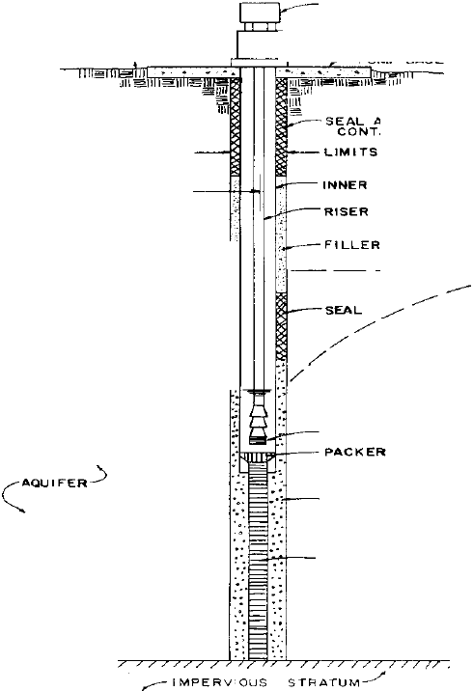

I=== ::J---YIELO T O STORAGE EX ISTING OR PUMPHOUSE

FLOOR

DEP T H TO STATIC WATER LE VE\.

s 'NAJ 2f 1 0u. RFACE

OF EXCAVATION

RA D US OF IHFL\LNCE CASING

I--S-TA-TIC WATE R LEVEL ;i

PI P E

: - - -

------ --;

- - ------

CONEO. .-"'

DEF'RESSION

DRAW DOWN

'-..

'-..

1 PUMPING LEVEL') "'- "·:'

PUMP W I TI1 SCREEN

GRAVEL. PACK

SCREEN

NO T E ' NOT ALL I TEMS SHOWN A f<E "t.<.;Uiktl.l ON E \'£1n W LL

**Figure 2. Well in Bedrock**

MOTOR

YIELD TO STOAAIJI!:

-  ~~--~~t·· I..IMITS ()II" EXCAVATION

~~CA~~81NG

CII:M«NT OI'IOUT

.·

UPPI:R I..JMIT OF WATI!: A 81!: ARING IIIOCK

:1' MINIMU"'N.._---

:=S, ISOTTOM OF CASING

( _ : : T\JAEO AOCK

*;>*

ATION

"--- IMPI!:RVIOUS STRA TUM -...

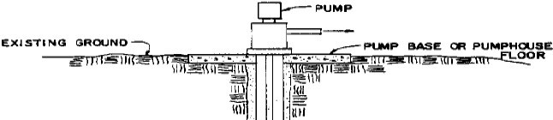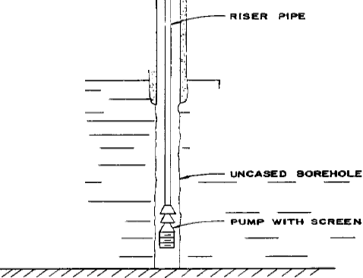

**7.1 WELL CASING**

**7.1.1 SURFACE CASING.** Steel surface casing shall be used at the driller’s discretion. This casing may be left in place or removed at the option of the driller. Steel casing should be driven 0.50 m into bedrock and cemented in place for its full depth, if it is to be left in place. All well surface casing shall be extended 0.5 meters above grade.

**7.1.2 WELL CASING DIAMETER.** The inside diameter for well casings shall be selected based on information provided in Table 3. The minimum diameter for any well casing shall be 150mm (6 in). Larger diameters shall be installed based on required well yield and the potential for future expansion. The diameter of a well has a significant effect on the well's construction cost. The diameter shall be uniform from top to bottom. In rare circumstances, construction may be initiated with a certain diameter casing, but drilling conditions may make it desirable to reduce the casing size at some depth. However, the diameter must be large enough to accommodate the pump. In addition, the diameter of the intake section must be sufficient to assure that the upward

velocity of the flow in the pump discharge pipe is 1.5 m/sec or less. The well shall be constructed to be straight and plumb. Other factors that control diameter are (1) yield of the well, 2) screen intake entrance velocity, and (3) construction method. The pump size, which is related to yield, usually dominates.

Approximate well diameters for various yields are shown in Table 3. Well diameter affects well yield but not to a major degree. Doubling the diameter of the well diameter will produce only about 10 to15 percent more water. Table 4 gives the theoretical changes in yield that result from changing from one well diameter to a new well diameter. For artesian wells, the yield increase resulting from diameter doubling is generally less than 10 percent. Consideration should be given to future expansion and installation of a larger pump. This may be likely in cases where the capacity of the aquifer material (such as coarse-grained gravels and unconsolidated conglomerate) is greater than well yield required for the current project.

The values in Table 4 are valid only for wells in unconfined aquifers (water table wells) and are based on the following equation:

Y2/Y1=(log R/r1)/(log R/r2) Eq. 1

Where:

Y2=yield of new well

Y1=yield of original well

R=Radius of cone of depression (mm)

r2=diameter of new well (mm)

r1=diameter of original well (mm)

**Table 3. Well Diameter vs. Expected Yield**

**(In SI and U.S. Customary Units)**

|  |  |  |  |  |  |  |  |  |  |  |  |  |  |  |  |  |  |
| --- | --- | --- | --- | --- | --- | --- | --- | --- | --- | --- | --- | --- | --- | --- | --- | --- | --- |
| **Expected**  **Well Yield** | | | **Nomi na l Si ze o f**  **Pump Bowls** | | | | | **Optimum Size of Well Casing** | | | | | **Smallest Size**  **Well Casing** | | | | |
|  | | |  | | | | |  | | | | |  | | | | |
|  | *(l p m)* |  |  | *(mm)* | | |  |  | *(mm)* | | |  |  | *(mm)* | | |  |
|  | | |  | | | | |  | | | | |  | | | | |
| <380 | | | 100 | | | | | 150 I D | | | | | 125 I D | | | | |
| 285-660 | | | 125 | | | | | 200 I D | | | | | 150 I D | | | | |
| 570-1515 | | | 150 | | | | | 250 I D | | | | | 200 I D | | | | |
| 1325-2460 | | | 200 | | | | | 300 I D | | | | | 250 I D | | | | |
| 2270-3400 | | | 250 | | | | | 350 OD | | | | | 300 I D | | | | |
| 3200-4900 | | | 300 | | | | | 400 OD | | | | | 350 OD | | | | |
| 4550-6800 | | | 350 | | | | | 500 OD | | | | | 400 OD | | | | |
| 6050-11400 | | | 400 | | | | | 600 OD | | | | | 500 OD | | | | |
|  | | |  | | | | |  | | | | |  | | | | |
|  | *(gpm)* |  |  | | *(i n )* |  | |  | | *(i n )* |  | |  | | *(i n )* |  | |
|  | | |  | | | | |  | | | | |  | | | | |
| <100 | | | 4 | | | | | 6 I D | | | | | 5 I D | | | | |
| 75-175 | | | 5 | | | | | 8 I D | | | | | 6 I D | | | | |
| 150-400 | | | 6 | | | | | 10 I D | | | | | 8 I D | | | | |
| 350-650 | | | 8 | | | | | 12 I D | | | | | 10 I D | | | | |
| 600-900 | | | 10 | | | | | 14 OD | | | | | 12 I D | | | | |
| 850-1300 | | | 12 | | | | | 16 OD | | | | | 14 OD | | | | |
| 1200-1800 | | | 14 | | | | | 20 OD | | | | | 16 OD | | | | |
| 1600-3000 | | | 16 | | | | | 24 OD | | | | | 20 OD | | | | |
| 3000-6000 | | | 20 | | | | | 30 OD | | | | | 24 OD | | | | |

Note: *If provided, contract section 01015 technical requirements shall supersede the minimum diameters suggested in this table.*

**Table 4. Change in Yield for Variation in Well Diameter**

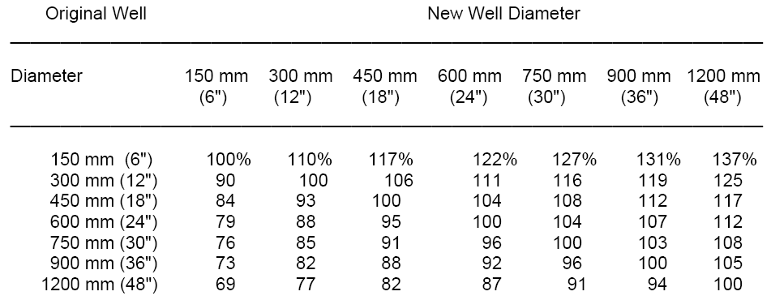

Note: *The above gives the theoretical increase or decrease in yield that result from changing the original well diameter to the new well diameter. For example, if a*

*300 mm well is enlarged to a 900mm well, the yield will be increased by 19 percent.*

**7.2 WELL AND CASING DEPTH.** Depth of a well is usually determined from the logs of test holes or from logs of other nearby wells that utilize the same aquifer. However for contract purposes, a minimum depth is usually specified in either the contract 01015 (Technical Requirements) or in the water well guide specification. A well that is screened the full length of the water bearing stratum has a potential for greater discharge than a unit that is not fully screened. Where the water-bearing formations are thick, cost may be the deciding factor in how deep the wells are installed. Cost, however, is normally balanced by the savings from a potentially long-term source of water. Well casing should not be founded on bedrock, since the weight of the casing and any other loads transferred to the casing from the construction features may exceed the buckling strength of the casing. The wall friction of the casing after sealing, grouting and well gravel packing should be designed to bear the vertical load on the casing.

**7.3 CASING MATERIAL.** The allowable casing material is steel (ASTM A53 Grade B or ASTM A139 Grade B). Use of PVC is not authorized. The casing in a well developed in a sand and gravel formation should extend a minimum of 4 m below the lowest estimated pumping level. In the percussion method of drilling, and where sloughing is a problem, it is customary to drill and jack the casing to the lower extremity of the aquifer, install the appropriate size screen inside the casing, and then pull the casing back, exposing the screen to the water-bearing formation. The wall thickness and pipe strength for the casing material depend on the hydraulic collapse and buckling strengths required for the well. Substitution of other pipe material shall first be approved by providing a shop submittal (Form 4025) with material specifications sufficient to evaluate the pipe strength for the proposed well application. The minimum wall thickness for steel pipe used for casing is 8 mm. Table 5 provides minimum pipe wall thicknesses for various diameters:

**Table 5. Minimum Steel Pipe Casing Wall Thicknesses**

**By Well Diameter**

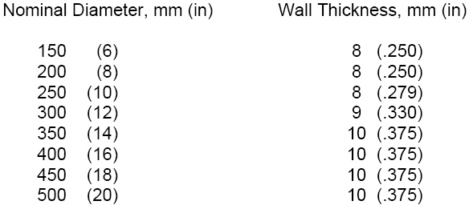

**7.4 WELL SCREENS.** Well screen shall be 304 stainless steel, wire-wrapped, and with a slot size between 0.7 and 1.0 mm (unless specified differently by the COR). Ideally well screens are designed based on the type of aquifer material encountered during drilling. This requires accurate depth information correlated to samples of the material at various depths and changes in strata. It is often not practical or feasible to perform these tests, because it is a requirement that all equipment and supplies be acquired, and located at the well site before drilling can commence. This includes the well screen and gravel pack material.

There will be situations (high pumping rates or large design populations) when the well screen and filter pack must be designed to match the geologic materials. If specified by the COR, the

Contractor will perform the appropriate design calculations (Appendix B) and supply the specified well screen and filter pack.

Naturally-developed wells are not allowed because they do not allow for the installation of the bentonite seal. The minimum inside diameter of the well screen shall be 150mm. A properly designed screen allows the permeability of the water bearing materials around the screen to be utilized. The screen and filter pack function to restrain sand and gravel from entering the well, which would diminish yield, damage pumping equipment, and deteriorate the quality of the water produced. Wells developed in fractured bedrock areas do not need screens if the wall is sufficiently stable and sand pumping is not a problem. Appendix A shows examples of acceptable and unacceptable well screens.

Screen length depends on aquifer characteristics, aquifer thickness, and available drawdown. The minimum screen length of stainless steel screens shall be two (2) meters. For a homogeneous, confined, artesian aquifer, 70 to 80 percent of the aquifer should be screened and the maximum drawdown should not exceed the distance from the static

water level to the top of the aquifer. For a non-homogeneous, artesian aquifer, it is usually best to screen the most permeable strata. The top of the screen will be at least 4m below the lowest drawdown level reached during the testing.

Homogeneous, unconfined (water-table) aquifers shall be equipped with screens covering the lower one-third to one-half of the aquifer. A water-table well is usually operated so that the pumping water level is at least 4 meters above the top of the pump. Screens for non- homogeneous water table aquifers are positioned in the lower portions of the most permeable strata in order to permit maximum available drawdown. The following equation shall be used to determine if a screen length greater than the minimum screen length stated above is required:

L=Q/(AV(7.48)) Eq. 2

Where,

L=length of screen (ft) Q=discharge (gpm)

A=effective open area per foot of screen length (ft2/ft). Approximately ½ of the actual open area which can be obtained from screen manufacturers.

V=velocity (fpm) above which a sand particle is transported; is related to hydraulic conductivity as shown in Table 6.

Centralizers will be placed at the top and bottom of each section, and at intervals of 8 meters of screen to maintain the screen position in the center of the hole. If the screen l ength is greaterthan 8 meters, a 1 meter l ength of blank casing shall be placed i n the middle of the screen interval for placement of centering devices. Centering devices will not be placed on the screened interval.

**Table 6. Estimated Sand Transport Velocities**

**Hydraulic conductivity Velocit y sand transport**

|  |  |  |  |
| --- | --- | --- | --- |
| m/day  204 | gpd/ft ^2  5,000 | m/min  3.05 | ft /min  10 |
| 163 4,000 2.74 9 | | | |
| 122 3,000 2.44 8 | | | |
| 102 2,500 2.13 7 | | | |
| 82 2,000 1.83 6 | | | |
| 61 1,500 1.52 5 | | | |
| 41 1,000 1.22 4 | | | |
| 20 500 0.91 3 | | | |
| 10 250 0.61 2 | | | |

The screen diameter shall be selected so that the entrance velocity through the screen openings will not exceed 0.03 m/s (0.1 foot per second). The entrance velocity is calculated by dividing

the well yield in cubic feet per second by the total area of the screen openings in square feet. This will ensure the following:

• The hydraulic losses in the screen opening will be negligible.

• The effect of incrustation will be minimal.

• The effect of corrosion will be minimal.

**Table 7. The relative open space in the screen as a function of screen diameter and slot size.**

|  |  |  |  |  |
| --- | --- | --- | --- | --- |
| **Relative Open Space vs. Diameter and Slot Size** | | | | |
| **Nominal Well Screen Diameter** | **Screen Slot Size** | | **Steel**  **Continuous Slot** | |
| ***mm*** | ***No*** | ***mm*** | ***cm2/m*** | ***%*** |
|  |  |  |  |  |
| 100 | 20 | 0.508 | 931 | 25 |
| 100 | 60 | 1.524 | 1,905 | 52 |
| 150 | 30 | 0.762 | 1,693 | 25 |
| 150 | 60 | 1.524 | 2,857 | 41 |
| 150 | 95 | 2.413 | 3,492 | 51 |
| 200 | 30 | 0.762 | 1,629 | 16 |
| 200 | 60 | 1.524 | 2,857 | 28 |
| 200 | 95 | 2.413 | 3,851 | 38 |

**Figure 3. Minimum Effective Open Area versus Well Yield**

30%

**Effective Open Area of Screen Length, percentage**

25%

20%

15%

10%

5%

0%

0 2 4 6 8 10 12

**Expected well yield, l/sec**

100 mm diameter screen

200 mm diameter screen

150 mm diameter screen

**7.5 FILTER PACKING.** Filter packing (sometimes referred to as gravel packing) is sand and gravel placed around the well screen to stabilize the aquifer and provide an annulus of high permeability around the screen. This differs from the naturally-developed well in that the zone around the screen is made more permeable by the addition of coarse material. Grain size of the filter pack is ideally selected on the basis of information obtained from sieve analyses of the material in the aquifer. Information on how to make these calculations is included in Appendix B.

Filter pack materi al shall be a product of a commercial sand and gravel supplier, shall be properly sized and graded for the surrounding soil encountered, and shall be composed of clean, round, hard, water-worn

siliceous material, free of flat or elongated pi eces, organic matter, or other forei gn matter. It must conform to the following criteria:

• The well-screen aperture size will be selected so that between 90 and 100 percent of the filter pack is larger than the screen openings. Refer to Table 8 for slot size and corresponding sieve size. For example, if the well screen has a slot size of 0.7 mm, between 90 and 100 percent of the material cannot pass through a size 25 sieve.

• A uniformity coefficient of less than 2.5 for the filter pack is required. The uniformity coefficient is defined as 40 percent of the retained grain size divided by 90 percent of the retained grain size.

• Filter pack material should be composed of clean rounded sand or gravel. Angular grains reduce pumpage and increase the drawdown. Pure silica sands are preferred because there is no loss of material due to solution effects.

• It is important that the filter used for packing be clean. If composed of local materials, it must be disinfected by immersion in strong chlorine solution (50 mg/L or greater available chlorine concentration, prepared by dissolving fresh chlorinated lime or other chlorine compound in water) just prior to placement. Dirty filter pack must be thoroughly washed with clean water prior to disinfection and then handled in a manner that will maintain it in as clean a state as possible.

**Table 8. ASTM Standard Sieve Sizes**

Opening size ASTM Sieve

*mm in No*

0

|  |  |  |
| --- | --- | --- |
| 4.76 | 0.187 | 4 |
| 2 0.079 10 | | |
| 1.2 0.05 16 | | |
| 1.0 0.0394 18 | | |
| 0.707 0.0278 25 | | |
| 0.5 0.0197 35 | | |
| 0.25 0.01 60 | | |
| 0.1 0.004 14 | | |

The thickness of the filter pack will range from a minimum of 75 mm (3 in) to approximately

200 mm (8 in). A filter envelope thicker than about 200 mm (8 in) will not greatly improve yield and can adversely affect removal of fines, at the aquifer-filter pack interface, during well development. Filter pack should extend one meter above the screen but not above the top of the aquifer. A tremie pipe will be used to evenly distribute the filter material around the screen and also to prevent bridging of the sand grains.

The Well Completion Submittal shall include:

(a) Number of screens and depth of setting in the well.

(b) Size of well screen inside and outside diameters and length. (c) Pipe material (material schedule and specification).

(d) Standard slot opening, mm

(e) Effective open area of screen (sq cm per meter) (f) Transmitting capacity (liters/meter)

(g) Sieve analysis of the material to be screened

(h) Calculations supporting screen slot size

(i) Photo of screen slot pattern

(j) Results of Gravel Pack selection analysis.

**7.6 GROUTING AND SEALING.** Wells must be constructed to prevent water that is polluted or of otherwise unsuitable quality from entering the well. Grouting and sealing of wells are necessary to protect the water supply from pollution, to seal out water of unsatisfactory chemical quality, to protect the casing from exterior corrosion and to stabilize soil, sand or rock formations that tend to cave.

**7.6.1 BENTONITE SEAL**. A bentonite seal with a minimum thickness of three meters shall be placed directly above the filter pack to prevent vertical infiltration of contaminants through filter material into the well. If the bentonite is installed in dry form, such as chips or pellets, there must be sufficient time given so that the bentonite can hydrate and form the seal. Allow three hours for hydration times, or per manufacturer’s guidelines.

**7.6.2 NEAT CEMENT/GROUT**. Neat cement or grout must be placed from the top of the bentonite seal and extends from the bentonite seal to approximately 2 meters from the ground surface. This seal is continuously placed from the bentonite seal to the surface. The annular space between the well casing and the walls of the hole shall be filled with cement-bentonite grout mix as hereinafter specified. The cement-bentonite grout mix shall be proportioned of Portland Cement conforming to ASTM Specification C150, Type I or II and bentonite (either sodium bentonite or calcium type morillonite or opalite). The cement-bentonite mix shall be proportioned, by weight, as follows;

6.6 : 1 : 0.4 (water : portland cement : bentonite). The water-cement (w/c) ratio shall not exceed 7. The mix shall be prepared as follows: the cement shall be mixed with the water first at the w/c

ratio prescribed above. At this stage, the mix is like grey water. Next, bentonite powder shall be slowly added such that clumps of bentonite do not form. This should be constantly checked by scraping the bottom of the mixer with a shovel. When clumps form, slow down and do not add any more powder until they are dissolved. Bentonite shall be added until the watery mix transitions to an oily/slimy consistency. Observe the consistency while mixing and allow the grout to thicken for another five to ten minutes. Generally, the mix thickens with added mixing

time. Bentonite shall be added as required. The mixture should form craters at the surface when it is the proper consistency for placing down the tremie pipe.

The cement-bentonite grout shall be forced from the bottom of the space to be grouted towards the surface by use of a tremie pipe. The minimum depth of grouting shall be three meters unless approved in writing by the COR. The grout shall also seal off any other water-bearing strata

above the zone providing water to the well. The grouting shall be done continuously and in a manner that will insure the entire filling of the annular space in one operation, without damaging the well casing. No drilling operations or other work in the well will be permitted within 24 hours after the grouting operation to allow the grout to properly set.

Establishment of good circulation of water through the annular space to be grouted is a highly desirable initial step toward a good grouting job. This assures that the space is open and provides for the removal of foreign material.

If a deeper, confined aquifer contains undesirable water, care should be taken during drilling so as not to penetrate or breach the confining unit separating the two aquifers. Any portion of the confining unit that is breached should be replaced with grout.

**7.6.3 CEMENT SURFACE SEAL**. The well annulus must be filled with cement from the top of the neat cement/grout seal to the land surface. The cement supplies structural support for the well

casing and above-grade piping and parts and keeps fluids out of the well.

**7.7 ACCESSIBILITY.** The well location shall be readily accessible for pump repair, cleaning, disinfection, testing and inspection. The top of the well shall never be below surface grade. At least 600 mm (2 ft) of clearance beyond any building projection shall be provided.

**7.8 DETAILS RELATING TO WATER QUALITY.** In addition to grouting and sealing, features that are related to water quality protection are:

**7.8.1 LOCATION**. The well or wells should be located on the highest ground practicable, certainly on ground higher than nearby potential sources of surface pollution. The surface near the site should be built up, by fill if necessary, so that surface drainage will be away from the well in all directions. Where flooding is a problem, special design will be necessary to insure protection of wells and pumping equipment from contamination and damage during flood periods and to facilitate operation during a flood.

**7.8.2 CONCRETE COVER.** The well casing should be surrounded at the surface by a concrete slab having a minimum thickness of 100 mm (4 in) and extending outward from the casing a minimum of 600 mm (2 ft) in all directions. The slab should be finished a little above ground level and slope slightly to provide drainage away from the casing in all directions.

**7.8.3 CASING HEIGHT**. The well casing should extend at least 500 mm (20 in) above the level of the concrete surface slab in order to provide ample space for a tight surface seal at the top of the casing. The type of seal to be employed depends on the pumping equipment specified.

**7.8.4 WELL HOUSE.** A permanent well house is required, the floor of which can be an enlarged version of the surface slab. The floor of the well house should slope away from the casing toward a floor drain at the rate of about 1 mm per 50 mm (1/8 inch per foot). Floor drains should discharge through carefully jointed 100 mm (4 in) or larger pipe of durable water-tight material to the ground surface 6 m (20 ft) or more from the well. The end of the drain should be fitted with a coarse screen. Well-house floor drains ordinarily should not be connected to storm or sanitary sewers to prevent contamination from backup.

The well house should have a large entry door that opens outward and extends to the floor. The door should be equipped with a good quality lock. The well house design should be such that the well pump and drop-pipe can be removed readily. Any structure built over the well must have a large door in the roof that allows for easy removal of the pump piping and pump using an overhead crane. The well house protects valves and pumping equipment and also provides freeze protection for the pump discharge piping beyond the check valve. Where freezing is a problem, the well house should be insulated and a heating unit installed.

The well house should be of fireproof construction. The well house also protects other essential items. These include:

• Flow meter (totalizer)

• Backflow prevention devices on the above-ground well discharge piping;

• Manual aboveground shutoff vWaelvll ePdumowpsns&trWeaemll Doefsbiganckflow device;

• Pressure gage

• Screened casing vent

• Sampling tap

• Commercial submersible pump protector

• Water treatment equipment (if required)

• Well operating records

**7.8.5 SECURITY**. The well building shall be protected from unauthorized use by a security fence having a lockable gate.

**7.9 WELL PUMPS**

**7.9.1 PUMP TYPE.** Many types of well pumps are on the market to suit the wide variety of capacity requirements, depth to water and power source. Electric power is used for the majority

of pumping installations. Where power failure would be serious, the design should permit at least one pump to be driven by an auxiliary engine, usually gasoline, diesel or propane. The most appropriate type is dictated by many factors for each specific well. Factors that should be considered for installation are:

• Capacity of well

• Capacity of system

• Size of well

• Depth of water

• Type of well

• Power source

• Standby equipment

• Well drawdown

• Total dynamic head

There are several types of well pumps. The most common are line shaft turbine, submersible turbine, or jet pumps. The first two operate on exactly the same principal; the difference being where the motor is located. Line shaft turbine pumps have the motor mounted above the waterline of the well and submersible turbine pumps have the motor mounted below the water line of the well.

ANA and ANP projects commonly employ small submersible turbine pumps; however, there may be projects where other types are preferable. For deep wells with high capacity requirements, submersible or line shaft turbine pumps are usually used and are driven by electric motors. A number of pump bowls may be mounted in series, one above the other to provide the necessary discharge pressure. A partial listing of pumps commonly used in water-supply wells are listed in Table 9.

Depending upon the depth of the static water level (<100m), a standard hand pump with seal and air gap shall be installed on the permanent well discharge piping to discharge at concrete pad around well. Hand pump components will be stainless steel. The hand pump shall be capable of pumping at a minimum pressure head of 138 Kpa (20 psi) in the event there is either a loss of power supply or a pump failure in the water well system.

**Table *9.*** Charaderistics **of** Pumps Used**in**Water **Supply** Systems

**Typt: uf rwn.,**

Practical Usual -11· Usual

**suc:tlon pumping pu.rc .A.dv(ullag J Disa«lva.ntages Remar ks**

lift deplhs heads

1. Shallow well .. 22-26 ft. 21-26 ft. 10 200 ft. I. Positi•e ac· 1. Pulsating *dis·* 1. Best suited for

2. Deep well ... 22-25 ft. Up to 600 Up to 800 lion. charae. capacities of >-25 feet **feet abo\'e** 2. Di..:luon:e 2. Su bJect IO Vi· **gpm a1ainst moder-**

c linder. **against vartal>Ie bration and** ate to high heads. heads. noise. 2. Adaptable to

**3. Pumps water** 3. Maintenance band operation. ('OOtaiuing sand cost may be high. 3. Can be itL, taUed and silt. 4. May cause de- **jn very small diame-**

4. Especially structive pres· *tet* wells ( 2" ea-r

ada pt<:<! to low , ......, if operated ing).

capacity and bigb aaainst closed 4. Pwnp must oe lifts. valve. sd directly Dver

well (deep well

only}.

I. Shallow well 20 ft. maxi· 1 20 ft. 100-I SO fl. I. Stnootb, even. 1. Loses prime 1. Very ef6.cienl

a. straigbt cent rifu·

mwn **flow. easHr. pump for capadtif's**

,al (single stage! 2. Pumps water 2. EfO.:Iency de· above 50 gpm &

**containing sand** pends on operal· beads up to about

and silt. **ing undd.e5ign** 150 feet.

3. Pr=ure on beads & speed

system is veo &

free from shock.

**4. tow-starting**

torque.

S. Usuall)l relia-

ble and good set·

vice life.

**b. Regenerath·e** 28 ft.mal<i· 211 ft. 100-200 fl. L Same *as* 1. Same as 1. Reduction ill vane turbille type mum stralgbt cent rifu· st raight o:enlrifu· **pr-essure wJin·** (•in&le impeller) **gal except not t::al ex«.:epl m&o· creased capacity not**

suitable for tains ptiminll **as severe as**

pumping water easily. straight centrifugal. containing sand

or ,ut.

2. They are self-

priming.

2. Deep well

Impellers 5 ft. 10()...800 ft. **1.** Same as shal- I. Efficiency de·

a. Vertical line su bmerged low weD turbine. pends -on opetat- sbaft turbine ioc u nder desi,n (m ulti-stage l he•d & speed.

2. Rect.uire<l straitht .. u

lure enousb for turbine bowls and housing.

3. Lubrication &

alignment of shaft critical.

**4. Abrasion from**

**sand.**

**7.9.2 PUMP CAPACITY** – The design capacity of the pump must equal the system requirements. The design goal is for the well pump capacity to be capable of supplying one average day flow (ADF) in a time period specified in the contract documents. **However the capacity of the pump must never exceed the capacity of the well.** There are many situations in which the aquifer can supply water, but at a rate which is less than the desired flow rate. For example, some facilities may only supply electricity for 6 hours per day. In these cases, it is not feasible to simply install a large pump to compensate for a higher required flow rate. The aquifer formation will only supply water at the rate it is able, and a larger pump will simply

burn out. There are several alternatives:

• Install a well field instead of a single well. Multiple wells may be able to supply the desired pumpage.

• Rely on the hand pump for periods when the well pump is without electricity and storage is depleted.

• Supplement water storage with hauled water.

• Increase the time which the generator operates so that water needs can be met.

Pump manufacturers publish charts giving the pump discharge capacity for their particular pumps at various operating pressures. The total dynamic head (TDH) of the system must be calculated accurately from the physical arrangement and is represented by the following:

TDH=HS+HD+HF+(V2/2g) Eq. 3

Where:

Hs=suction lift; vertical distance from the waterline at drawdown under full capacity to the pump centerline, m

HD=discharge head; vertical distance from the pump centerline to the pressure level of the discharge pipe system, m

HF=friction head; loss of head on pipe lines and fittings, m

V2/2g=velocity head; head necessary to maintain flow, m

The brake horsepower (engine horsepower with no power loss from associated components) of the motor used to drive the pump may be calculated from the following equation:

P=(HQ)/(102*e) Eq. 4

Where:

P=break power required, kW H=total dynamic head, m Q=volume of water discharged, L/s

e=Combined efficiency of pump and motor, from manufacturer’s data

Appendix C contains information for designers selecting of water well pumps.

**8. RECEIVE AED APPROVAL**

CONSTRUCTION OF THE FINAL WELL CANNOT START AND SHALL STOP until

receipt of AED Approval. Before any final well construction, AED shall receive, review and approve the Test Well Approval Submittal and shall authorize construction of the permanent well. Failure to follow the construction and submittal procedures outlined, may at AED’s discretion, result in rejection of the well and, the contractor having to remove the well casing and screen, re-drill the well and reinstall the proper features per the approved design. The contents of the Final Well Design Proposal shall include:

1. Proposed pumping rate.

2. Location and coordinates of well on site plan.

3. Size of well diameter and depth.

4. Driller’s Log Submittal.

5. Geology Log Submittal.

6. Water Well Summary Sheet (Appendix E)

7. Pump Selection Design.

8. Static and dynamic water table depths and elevations.

9. Casing and screen diameters and lengths installed in the test well.

10. Proposed permanent casing diameter and material.

11. Proposed permanent screen design and supporting calculations.

12. Proposed permanent grouting and sealing.

13. Proposed permanent gravel/filter pack design and materials and supporting calculations.

14. Step-test results, including Specific Capacity, Max Sustained Yield, and Radius of

Influence. (Hydraulic Conductivity will be reported if full pumping test was performed.)

15. Water quality results.

**9. CONSTRUCT PERMANENT WELL**

After receipt of AED concurrence, the permanent well can be constructed. If AED rejects the Well Design document or Report, then the contractor will amend or revise subject reports to achieve approval before final well construction can begin.

A stainless steel check valve (if not on the pump discharge piping), isolation valve, sampling port, and well-discharge totalizer shall be installed on the pump discharge pipe line, as minimum appurtenances, between the well head and the water storage treatment tanks. A water level measurement port shall be provided at the well head. Additional appurtenances such as flow meter, air release valve, and chlorination treatment piping may be required depending upon the contract technical requirements.

Upon completion of the well and other incidentals, all debris and surplus materials resulting from the work shall be removed from the job site. The drilling fluid shall be pumped out and properly disposed of and the excavation for the sump backfilled suitable to the site COR.

**10. DEVELOP AND DISINFECT WELL**

After the structure of the well is installed, there remain two very important operations to be performed before the well can be put into service. Well development is the process of removing the finer material from the aquifer around the well screen, thereby cleaning out and opening up passages in the formation so that water can enter the well more freely. Disinfection is the process

of cleaning and decontaminating the well of bacteria that may be present due to the drilling action.

**10.1 WELL DEVELOPMENT.** After construction is complete, the well shall be thoroughly developed. The developing equipment shall be of sufficient capacity to remove all drilling fluids, sand, rock cuttings or any other foreign matter. The wells shall be thoroughly cleaned from top to bottom before beginning the well tests. Three beneficial aspects of well development are to correct any damage or clogging of the water bearing formation which occurred as a side effect of

drilling, to increase the permeability of the formation in the vicinity of the well and to stabilize the formation around a screened well so that the well will yield sand-free water.

Development is necessary because many drilling methods cause increases in the density of the formation around the hole. Methods utilizing drilling fluids tend to form a mud cake. Good development will eliminate this "skin effect" and loosen up the sand around a screen. Removal of fines leaves a zone of high porosity and high permeability around the well. Water can then move through this zone with negligible head loss.

Methods of development in unconsolidated formations include the following:

• Mechanical surging is the vigorous operation of a plunger up and down in the well, like a piston in a cylinder. This causes rapid movement of water which loosen the fines around the well and they can be removed by pumping. This may be

unsatisfactory where the aquifer contains clay streaks or balls. The plunger should only be operated when a free flow of water has been established so that the tool runs freely. Swabbing is a type of surging utilizing a specialized plunger.

• Air surging involves injecting air into a well under high pressure. Air is pumped into a well below the water level causing water to flow out. The flow is continued until it is free of sand. The air flow is stopped and pressure in an air tank builds to 700 to 1,000 kilopascals (100 to 150 psi). Then the air is released into the well causing water to surge outward through the screen openings.

• Back washing involves reversal of flow. Water is pumped up in the well and then is allowed to flow back into the aquifer. This usually does not supply the vigorous action which can be obtained through mechanical surging.

• High velocity jetting utilizes nozzles to direct a stream of high pressure water outward through the screen openings to rearrange the sand and gravel surrounding the screen. The jetting tool is slowly rotated and raised and lowered to get the action to all parts of the screen. This method works better on continuous slot well screens better than perforated types of screens.

The well must be developed using surge methods and the overpumping development method is not permitted. Development in rock wells can be accomplished by one of the surging methods listed above or by one of the following aquifer stimulation methods.

• Acidizing can be used in wells in limestone formations. Fractures and crevices are opened up in the aquifer surrounding the well hole by the action of the acid dissolving the limestone.

• Sand fracturing is the action of forcing high pressure water containing sand or plastic beads in to the fractures surrounding a well. This serves to force the crevices open.

Development using explosives is prohibited. The recommended type of development for stainless steel screened wells is hydro-jetting; however surge blocks, air-development or other development techniques are permissible at the option of the Contractor. The well shall be disinfected before removing the test pump and collecting samples for determining the water quality.

**10.1.1 WELL DEVELOPMENT REQUIREMENTS --** A well development record shall be prepared. Development is complete when both of the following criteria are met:

1. Well water is clear to the unaided eye and/or turbidity is less than or equal to 5

Nephelometric Turbidity Units (NTUs) and no sand is visible at the bottom of the sample container.

2. Sediment thickness in the well is less than 1% of the screen length.

If the Contractor has the appropriate instrumentation, then the following alternative development metric can be used. A minimum of three times the standing water volume in the well is removed plus three times the volume of all added water and drilling fluid lost during drilling and installation of the well is removed, and Temperature, specific conductivity, pH, oxidation-reduction potential (ORP), dissolved oxygen (DO), and turbidity readings, measured before, twice during and after development operations, have stabilized. Stabilization shall mean variation of less than 0.2 pH units, variation of ± 0.5 degrees C (1 degree F), ± 3 percent

change in specific conductance; and less than a ± 10mV for ORP; and ± 10 percent for DO, and turbidity, measured between three consecutive readings with one casing volume of water removed between each reading. ORP shall be determined in accordance with AWWA 10084. Temperature, specific conductance, DO, turbidity and pH readings shall be conducted in accordance with EPA 600/4-79/020.

Whichever development metric is used, at completion of well development, approximately

0.5 liter of well water shall be collected in a clear glass jar. The jar shall be labeled with project name, well number and date; and photographed using digital photography. The photograph (minimally 125 x 174 mm or 5 x 7 inch) shall be a suitably backlit close-up which shows the clarity of the water and any suspended sediment. The photograph and .jpg file shall become a part of the well development record.

**10.2 WELL DISINFECTION**. The well shall be disinfected to remove bacteriological contamination that may cause the well-water supply to be unsafe for human consumption. The chlorine solution used for disinfecting the well shall be of such volume and strength and shall be so applied that a concentration of at least 50 mg/L of available chlorine shall be obtained

for the entire water depth of the well, and this solution shall remain in the well for a period of at least 12 hr.

If the samples collected after disinfection show bacteriological contamination, the contractor shall prepare and apply to the entire depth of the well a total volume of the chlorine solution of at least 100 mg/L of available chlorine equal to at least four times the volume of water in the well. The contractor shall allow this solution to remain in the well for a period of at least 24 hr. Driscoll (1986, page 619, Appendix D) offers an excellent summary of disinfection

procedures.

**11. TEST WELL PERFORMANCE**

Upon completion of the permanent production well, the Driller shall conduct a continuous 6- hour pumping test at the designed flow rate. Drawdown will be recorded from time-zero at the following time intervals:

***First 5 minutes – every 30 seconds***

***Next 5 minutes – every minute***

***Next 50 minutes – every 10 minutes Next 2 hours – every 20 minutes Next 2 hours – every 40 minutes Last hour – one sample at end***

If water levels are recorded digitally with a transducer, smaller time intervals are often programmed into the software. This is acceptable. The above guidance serves as minimum time intervals.

After the 6-hour pumping test has been finished, but before the pumps are shut off, a second round of water-quality samples will be taken and tested for the same parameters as outlined in Section 5.2.

Recovery data will also be recorded at intervals described above. Recovery data will be recorded until drawdown reaches 90% of pre-pumping levels.

**12. SUBMIT WELL COMPLETION REPORT**

The design and construction documents must provide a permanent record of the well construction. Without this documentation, later attempts to evaluate the potential long term yield of a well, well pump problems, water quality, expected / actual yield, and the potential to increase production will be meaningless. Reporting requirements include the following:

• Drillers log

• Geology or Lithology log

• Geophysical logs (if performed)

• Water Well Summary Sheet

• Performance Pumping Test Report and Analysis

• Well Screen and Gravel Pack Design

• As-Built drawings

The Contractor shall submit editable CAD format As-Built drawings. The drawing shall show the final product as it was installed in the field, with the exact dimensions, locations, materials used, logs and any other changes made to the original drawings. Refer to Contract Sections 01335 and 01780A of the specific project for additional details.

**13. MULTI-WELL FIELDS**

The grouping of wells must be carefully considered because of mutual interference between wells when their cones of depression overlap. In this case, a full pumping test, with observation well(s), will be performed. Minimum well spacing shall be 75 m (250 ft). The total interference effect at a well is a function of the following:

• Number of wells being pumped.

• Distance from point of measurement to pumping wells.

• Volume of discharge at each well.

• Penetration of each well into aquifer.

For simple systems of 2 or 3 wells, the method of super position may be used to estimate well interference. The procedure is to calculate the drawdown at the point (well) of consideration and then to add the drawdown for each well in the field. For multiple wells, the discharge must be recalculated for each combination of wells, since multiple wells have the effect of

changing the depth of water. For large systems the following conditions should be noted:

• Boundary conditions may change.

• Change in recharge could occur.

• Computer analysis (numerical modeling) may be helpful to recalculate the combinations.

It is seldom practicable to eliminate interference entirely because of pipeline and other costs, but it can be reduced to manageable proportions by careful well field design. When an aquifer is recharged in roughly equal amounts from all directions, the cone of depression is nearly symmetrical about the well and is about the same in all directions. If, however, substantially more recharge is obtained from one direction; e.g., a stream, then the surface elevation of the water table is distorted, being considerable higher in the direction of the stream. The surface

of the cone of depression will be depressed in the direction of an impermeable boundary because little or no recharge is obtained from the direction of the impermeable boundary.

Where a source of recharge such as a stream, exists near the proposed well field, the best location for the wells is spaced out along a line as close as practicable to and roughly parallel to the stream. On the other hand, multiple water-supply wells should be located parallel to and as far as possible from an impermeable boundary. Where the field is located over a valley, the wells should be located along and as close to the valley's center as possible. In hard rock country, wells are best located along fault zones and lineaments in the landscape where recharge is greatest. These are often visible using aerial photographs. Special care should be exercised to avoid contamination in these terrains since natural filtration is limited. Wastewater is commonly recharging groundwater at these sites, and consideration should be given to expected flow patterns.

**13.1 RADIUS OF INFLUENCE CALCULATIONS --** The following definitions are necessary to an understanding of radius of influence calculations:

• *Static Water Level –* The distance from the ground surface to the water level in a well when no water is being pumped.

• *Pumping Level –* The distance from the ground surface to the water level in a well when water is being pumped – also called dynamic water level.

• *Drawdown –* The difference between static water level and pumping water level.

• *Cone of Depression* – The funnel shape of the water surface or piezometric level which is formed as water is withdrawn from the well.

• *Radius of Influence –* The distance from the well to the edge of the cone of depression.

• *Hydraulic Conductivity –* The rate at which water moves through the formation.

Units are expressed in length/time or gallons per day per square foot. It is governed by the size, shape, and interconnectedness of the pore spaces.

The well discharge equation (Eq. 5, also known as the Thiem equation) below is used to determine the amount of water that can be expected from a well or the radius of influence. The formula assumes certain simplifying conditions. However, these assumptions do not severely limit the use of the formulas. The assumptions are as follows: 1) the aquifer is unconfined (water table), of constant thickness, is not stratified and is of uniform hydraulic conductivity (i.e. homogeneous); 2) the piezometric surface is level, laminar flow exists and the cone of depression has reached equilibrium (i.e. steady state); and 3) the pumping well reaches the bottom of the aquifer and is 100 percent efficient.

The following equation is used to calculate the discharge: Q = (1.366K(H2-h2))/(log(R/r)) Eq. 5

Where:

Q = pumping rate (m3/day)

K = hydraulic conductivity of water-bearing unit (m/day) H = Static head from bottom of aquifer (m)

h = pumping head from bottom of aquifer (m) R = Radius of influence (m)

r = Radius of well (m)

Hydraulic conductivity (K) is equal to the aquifer transmissivity divided by the saturated aquifer depth. (Or T = Kb)

Figure 4 shows the relationship of the terms used in Equation 5 for available yield from a water table well. An existing well or monitoring well must be used to estimate the radius of influence of the proposed production well.

**Figure 4. Diagram of Water Table Well**

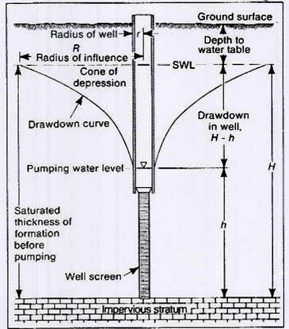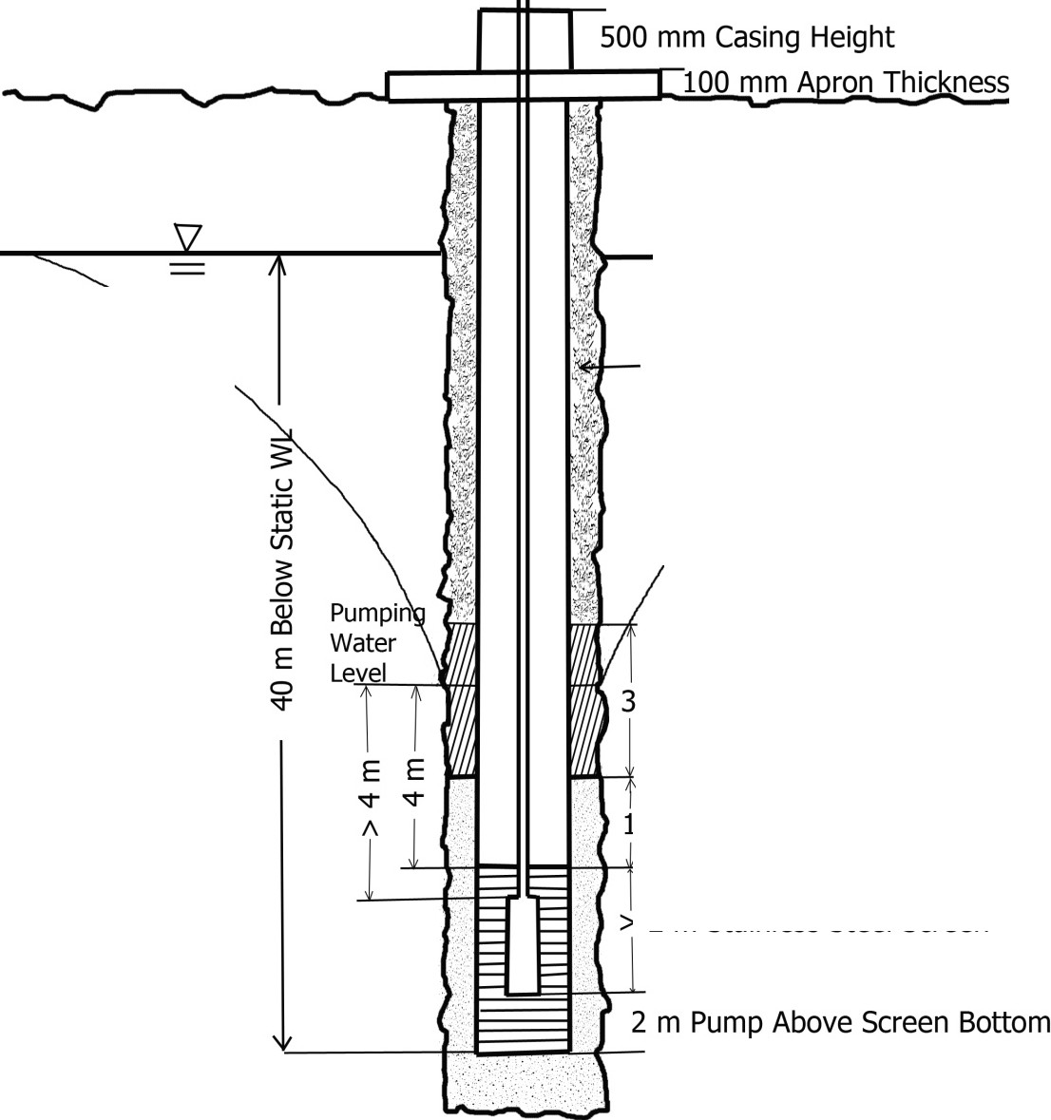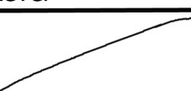

**Well Requirements**

[Target Velocity 1.0 - 1.5 m/sec

Static Water Level

> 3 m Cement-Bentonite Grout

3 m Bentonite Above Filter Pack

1m Filter Pack Above Screen

> 2 m Stainless Steel Screen

GAA 03/28/12

**Figure 5. AED Well Requirements**

**14. REFERENCES**

1. *Groundwater and Wells*, Fletcher Driscoll, Johnson Division, 1986.

2. UFC 3 230 07a, *Water Supply Sources General Considerations*, 2004

3. ASTM F480-06b *Standard Specification for Thermoplastic well Casing Pipe and*

*Couplings Made in Standard Dimension Ratios, SCH 40 and SCH 80*

4. ASTM D 1785-06 *Standard Specification for PVC Plastic Pipe, Schedules 40, 80 and*

*120*

5. ASTM A 53 *Pipe, Steel, Black and Hot-dipped, Zinc-coated, Welded and Seamless*

6. *Inventory of Ground-Water Resources in the Kabul Basin, Afghanistan, U.S.* Geological

Survey, Scientific Investigations Report, 2005-5090.

7. *Guidelines for Sustainable Use of Groundwater in Afghanistan, Norwegian Church Aid*,

2002

8. *Sanitary Control and Surveillance of Field Water Supplies*, TB MED 577, Department of

Defense 2005

9. World Health Organization, *Guidelines for Drinking Water Quality*, 2006

10. AWWA A-100-06 *Water Wells*

11. AWWA, C200, *Steel Water Pipe 6 Inches & Larger*

12. AWWA, C206, *Field Welding of Steel Water Pipe*

13. *Water Wells and Pumps*, Michale, A.M.; Khepar, S.D., and Sondhi, S.K., McGraw Hill,

2008

14. UFGS 33 20 00, *WATER WELLS*, Prep. by USACE, April 2008

15. ASTM, C-150, *Portland Cement*

16. TM 5-813-3 (UFC 3 230 08a Water Supply Water Treatment, January 2004).AWWA

10084, *STANDARD METHODS FOR THE EXAMINATION OF WATER AND WASTEWATER, 21ST EDITION*, 2005

17. EPA 600/4 - 79/020, *Methods for Chemical Analysis of Water and Wastes*, March 1979

18. DoD 4715.05-G, 2007, *Overseas Environmental Baseline Guidance Document*

**Appendix A**

**Examples of Unacceptable and Acceptable Well Construction**

**(Source: Statement of work Military Water Well Construction, Testing and Completion, United States Forces, Afghanistan, 2009)**

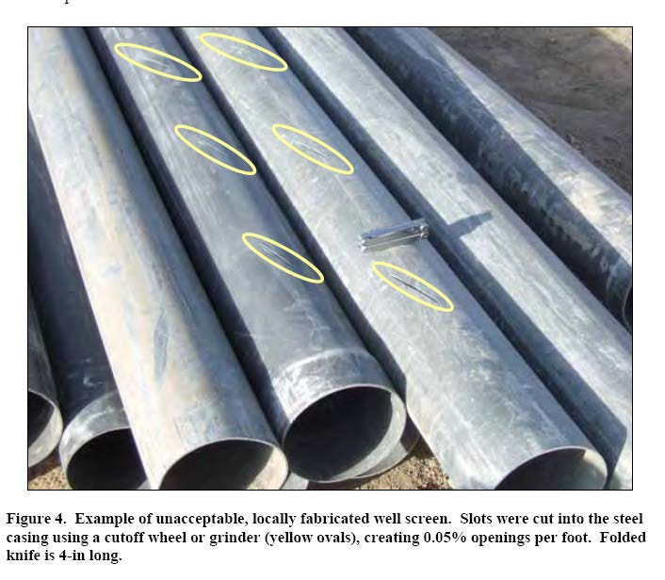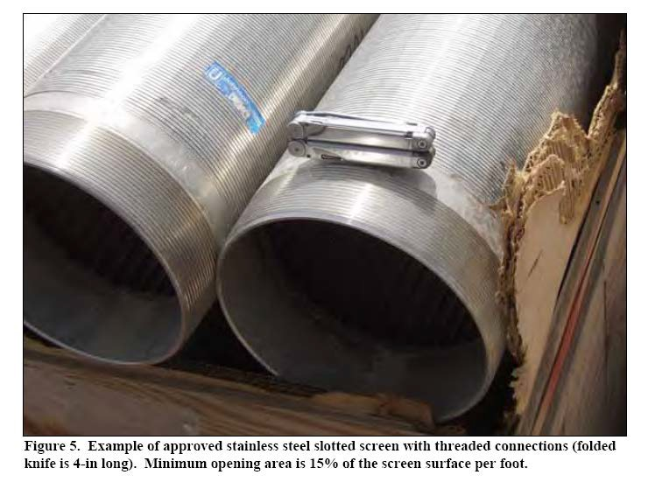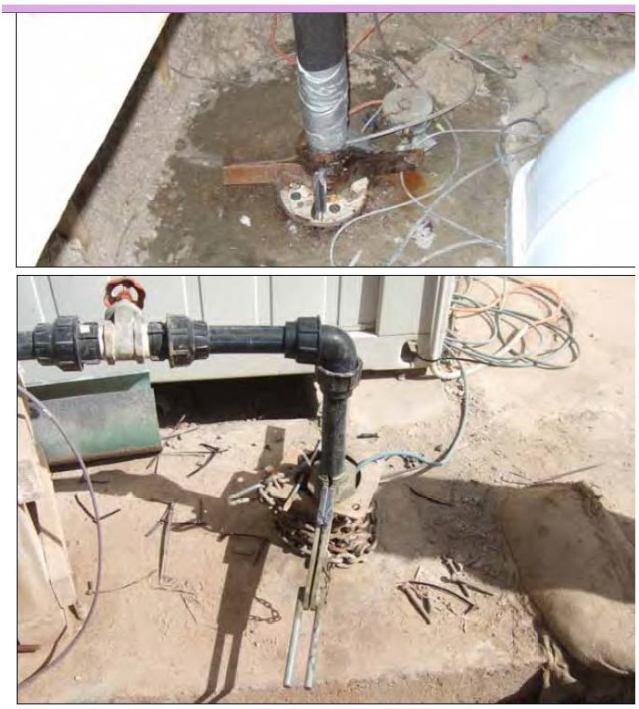

Figure 6. Unacceptable wellhead completion examples. Upper panel - casing sticks up <1-inc.IJ above the floor, has an inadequate sanitary seal, and has inadequate well pad slope aud floor drainage. Lower panel - uo sanitary seal or well house over well, aud !he well pad has no slop1

Both examples are missi112 totalizers, water samplin2 ports, water level measurin2 ports.

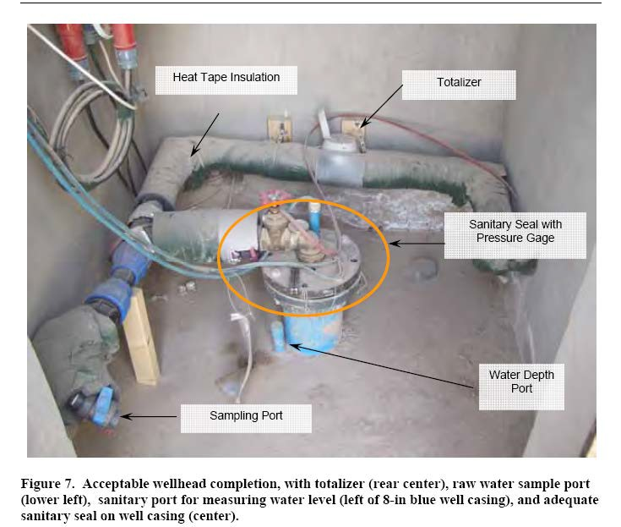

**Appendix B**

**Theoretical Well Screen and Filter Pack Design**

This section, and referenced text, will provide more information well screen and filter pack design. This is predicated upon depth-dependent data on aquifer materials, i.e. gradation curves for each aquifer zone which is to be screened.

The results of the analysis of any particular aquifer sample should be recorded as the percent (by weight) of the sample retained on each sieve and the cumulative percent retained on each sieve (i.e., the total of the percentages for that sieve and all larger sieve sizes). Based on these sieve analyses, determine the aquifer stratum which is composed of the finest material. Driscoll, page

409 (Appendix D), gives more information on determining grain-size distributions.

Using the results of the sieve analysis for the finest aquifer material, plot the cumulative percent of the aquifer material retained versus the size of the mesh for each sieve. Fit a smooth curve to these points. Find the size corresponding to a 70 percent cumulative retention of aquifer material. This size should be multiplied by a factor between 4 and 6, 4 if the formation is fine and uniform and 6 if the formation is coarse and non-uniform. Use 9 if the formation includes silt. The product is the 70 percent retained size (i.e., the sieve size on which a cumulative 70 percent of the sample would be retained) of the material to be used in the packing.

A uniformity coefficient of 2.5 for the filter pack is desirable. The uniformity coefficient is defined as 40 percent of the retained grain size divided by 90 percent retained size. Lower size represents a more uniform material and is more meaningful for values less than 5.

The plot of cumulative percent retention versus grain size for the filter pack should be approximately parallel to same plot for the aquifer material, should pass through the 70 percent retention value, and should have 40 and 90 percent retention values such that the uniformity coefficient is less than 2.5. Filter pack material will be specified by determining the sieve sizes that cover the range of the curve and then defining an allowable range for the percent retention on each sieve. The contractor shall verify these gradations are suitable for the specific well as not all aquifers are the same. Driscoll, pg 441 (Appendix D), gives more information on filter pack design.

**1.0 GENERAL**

**APPENDIX C**

**WELL PUMP SELECTION EXAMPLE**

The purpose of this appendix is to assist the contractor to fulfill the design and submittal requirements for projects requiring well pump selection and installation. Selecting the correct pump for a project is important for the sustainability of well operation and the efficient use of power to run the pump over time. In recent years, there have been a large number of pumps that required replacement at the ANA and ANP facilities. One of the reasons has been the incorrect selection of submersible pumps.

**2.0 DESIGN FLOW**

The first step is to determine the water demand and the amount of flow required of the pump per unit time. But remember **“The Capacity of the Pump Must Never Exceed the Capacity of the Well”.** The design flow is one of the first determinations for the site and it depends upon the design population x usage per day / hours of pumping per day. That result is multiplied times the capacity factor. The final number is a flow rate in quantity per unit time.

**3.0 HEAD REQUIREMENT**

The second step is to calculate the total head that the pump has to push against and overcome. There are different components contributing to flow resistance that can all be expressed in terms of head. But the head changes depending on the flow rate. So the objective is to determine total dynamic head based on the design flow.

modified from [www.pumped101.com](http://www.pumped101.com/)

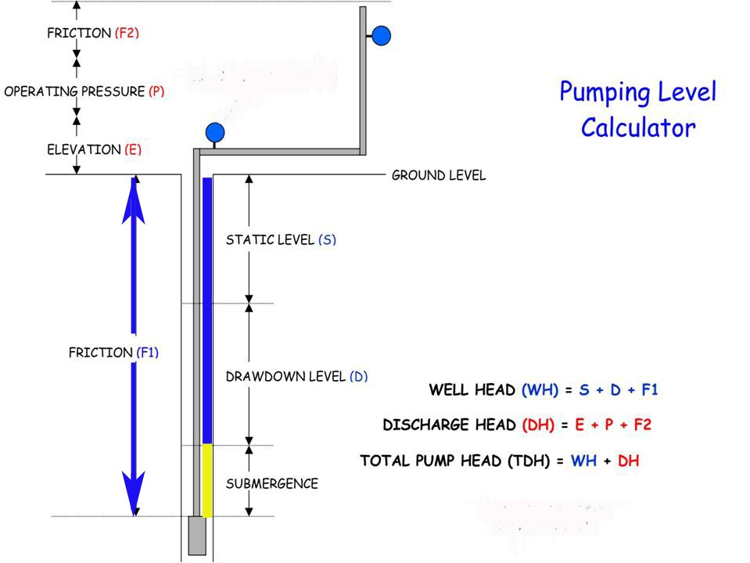

**3.1 Well Head**

The well head consists of heads that are below ground surface (bgs) and must be overcome to pump water to the surface. It includes overcoming friction in the pump discharge pipe as well as elevation heads.

3.1.1 Dynamic Water Level **--** The most common misunderstanding is in determining the water level for the “Well Head”. It is based on the difference in elevation between the ground surface and the dynamic water level. The dynamic water level equals the drawdown added to the static water level. The dynamic water level should be determined

during the step-drawdown pumping test when pumping at 100% of the design flow.

3.1.2 Friction Head (bgs) **--**The friction head depends upon several factors including the length of the pump discharge pipe, its diameter, the velocity of flow and the roughness of the pipe, reflected by the type of material from which it is made.

**3.2 Discharge Head**

The discharge head is a combination of heads that must be overcome once the water has been pumped to the ground surface. They include: the elevation head, the operating pressure and the friction head from piping at or above the ground surface.

Elevation Head – The most common elevation head at ANA and ANP sites is the 20m height of the elevated storage tank.

Pressure Head – There is commonly little or no pressure required for the ANSF systems.

Friction Head – There is the friction head from any pipelines that transmit water to the storage tank. Also there are fixtures such as elbows, Ts, flow meters etc. that should be

determined and their contribution to head added to the total discharge head.

**3.3 Total Pump Head**

The total pump head is the well head and discharge head combined. There is also the velocity head but it is negligible.

**4.0 SELECT FAMILY OF PUMPS**

The third step is to select a general category or family of pump curves. The primary determination is based on the design flow rate but the total head is also a factor. Select a pump family that is in the range of design flow needed.

From: [www.pedrollo.com](http://www.pedrollo.com/)

Family of Performance Ranges

Pump Design is Based on Flow Rate and Head.

6-inch Pump

Water Requirement =

43,594 L/h

44 m3/h = 44,000 L/h

Select 6SR44 for example

**5.0 SELECT PUMP**

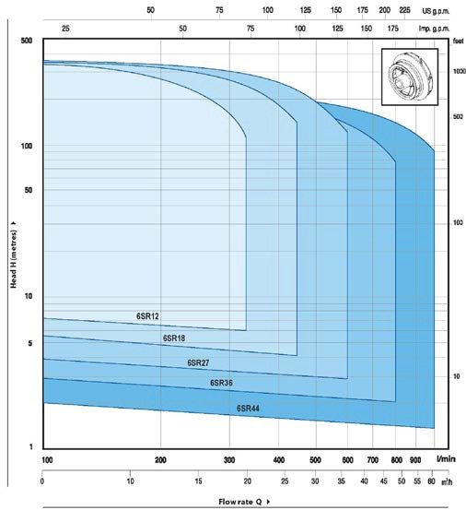

Look at the pump curves from the family of pumps selected. Based on the total head that was calculated, select that point on the y-axis. Then look along the x-axis for that point and find the curve that is nearest to the peak of the efficiency curve. The point where that line crosses the pump curve is the “Duty Point.” Look down to the x-axis and that is the flow rate that can be expected. If that is inappropriate one may need to try another family of pumps or another manufacturer.

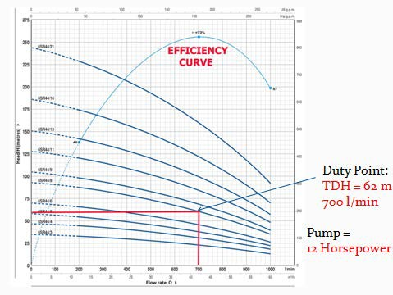

AED Design Requirements

Well Pumps & Well Design

**Appendix D.**

**Sited References from Driscoll, *Groundwater and Wells*, 1986**

42

wn.LSOUENS Af'o"l) MtntOI:SOFSEJ>t.MCIT.SIZ£ ANALYSIS 409 410

C.ROV 1>WATI!R .u<O V.'I:U.S

2nd the cumulati,·e amount ofm:uc:fial measurW.. These ''ofume5C3n then be ploued in a manner 5imilu tO the prooedure djsw.s.s«J above. It is i1S$umall the material bls essentially the same density.'Thh mtlhod is not as r:ue a.s a laboratory sie,·e

anal)'$ls or Sl'dimtntation proctdure.

Crtin...Slxe Distribation Cu.n·e

Table 12.6. Craln-Size Oasslfi('lltioa

Wfflh (.'\lou.f.-. Sin Slllotr

lo.o& On *1t.* tbow (154

""""''

mm*1t.* •bow)

The Wentworth sc le, dcvelopl'd in

192:2, is still the buic J)Sttick siZl' clas­ sification used in the groundwater field. The United Sta t es Gtolosic.al Survey (USGS) uses this classification but bu

Thevain tize d istribution curve sbowut a Jlan« how much oftbc sample material is smaller or larJCr tban a gi ven pan:icJe. Sze.. for CJ(Jiml)le.the turvt' i.n fi&ure 12.16

l.Uto 10.01._

(64 10 1mm)

-""'"·"

O.t610 Ul in

takea one $-i:u ran,&e., 0.16 to 2.5 i.n (4 to

64 mm). ;uld subdivided i1 into SfOI.IJ)$.

Tbe

shov.•s that 90 percent or the sample oonsist.s of sand arains lat er tha.n 0.009 in (0.23

mm) and 10 percent i.$ smaller than this size. ReadiO$ tbe c .n·e in another way. the

41).perttnt sand size is 0.026 in (0.66 mm); or 40 pcn::c:nt or tbe sample is coarser than 0.026 in and 60 percent is finer than. 0.026 in.

Grain-size distribution et. rves have many applications other than in the water wcll ind·unry.They are used to represent the pdi na or eonerete sand, foundty sand,l'anh materials for embankments and dams., filter sands.. and many other types of ganuLar matui.als. Engineers i n thew different fiCids I.ISC several variations in plottina the

curves. Attention is (allcd to this fact bteausc thett: may be occasion tO usc ani»·

(4106-im.m)

(ioanuk om10 0.16 in

«"'"l' fiM lfl''dt (2 104 ffllll)

*\'«y* CO.IW -.1 o.o. 10 o.oc ••

(110 2 mm)

Ctl.lfld 0.0110O.Ool •

(OJ to I ft'lm)

Mild M110 Mlio

Wentworth seale aoo USGS amend•

ments are shown in Tabk 12.6.

The c.Ut\'C in Fisure 12.16 shows th3t the sampk tested consists of medium and coarse Pnd,:t.crord.irS to the USGS cl:t.s· sification. Appl yins tbe same system to tbe fo\lr eur,es in Fi.&ures 12.19 to 11.22

JivC$ the followins descriptions: Class A eur,e -fine sand

size distribution curves that are plotted difl'ercntl'y than th05e dis;cus.sed bere.

ln the most oommon varialioo,perttnt of material passi.llJ a a,iven sie,·e is plotted on the ,.e-.·. tkal scale iostcd of pcrct1'H tttained.This ha.s tbc eff'w or re,etsin.& the

e . rve so it slopes upward fm left to ritJlt instc:Jd or downward. lio ,·er, plottina

pc:roel'lt retained on tbc ,·erlil'al scale is the lo&,ical procedure beCause thi.s penniu

(0.1S "' o.s ->

Fine sand 0.00100.01i•

(0.125 to 0.25 m)

VftyfiMIUid 0.00110o.cm 111

(0to o.t2J• m)

0.0001100.001in

Class 8 curve -fine :.nd very

*@t$C* sand

Class C cur,e -coarse and very coarse sand

Cla$$ I) eu.rve -coarse sand aDd very fine gravel

)>

rom

=0

-oo

cro

, s;ing the cumulath·e wei&J'Its in tht samt manner that they are rdcd in the lal>

"'"

tO.O:W 10 0.06l mm)

Othrr W•rs to l)es(rlbe Sedimeat Size

3 !!!.

oratory. To pennit plotting pcroent passifls. on tbe otbcr hand, the percent retained must be subtracted from 100.

w A second variation is the usc of a loprithmie scaJe for the panicle size or sie,e

opcnina. This hu the efftet of elonptifll the part of the curve that represents the finer frac1ion, and squ.ttti n.& that part oftbe Cl.lrve rcpttstntin.a the COII'$Cr matcrdl. No single tum or word can be used to pve an ovttall description of a and or sand aDd cravt:l mixture. bttausc the rru terial coru.im or the whole raQiC *of* part.icle i.us. Between the limiU of the smallest and a Jl'$1 panic;le sites, the iQtermediate sUes can be distributed in many different ways. and each distribution eha.n&cs the shape

of the c;urve.

There ilre three elements esse-ntial to a eom,pltte <kscription of a pain•size distri· bu tion cur,·e:(I ) sediment size (finenCS1 or coatstneu):(2) slope of tbe curve; and (3) sbape of the curve. Any of these demtnts ean dt.ati.JC independently of the others. and this makes it nceessary to 1.11e all thne for a com plete de&eriplion of the material

a:radinc.

..,., $dow0.0002 in

(fldow 0,.006 1M\)

"1llc< USGS hal illbdlvlded

lhllQ141)ry At fol

V ry(OIIJCI!Jr$-rd I.26101Jli.

()2 loo-4 rnm)

Colnc Sftvd 0.63"' 1..16ill

(16 10 *n* mm.)

Medo-pt>1'1 OJIIIOG.4) in

(8to 16...-)

1'\ !Jr*Vd 0.16to0,)1 in

<• 10 8 cnm)

*(KnutfM.,.*cl *Pt'lt(jo/tl\. 19J8)*

Oflen.a specific point on a g.rain-siu distribution curve is used a.s a &eneral in· dtJt of fineness. An attempt i.s then made to oorreJate this siz.e v.itb the hydraulic ooftductivity of the K<Siment.Several sc­ lttted si.us have beet'l used by v rious researcben.

The tem'l "effective sil;e" v.·as devel­ oped by Alkn Hazen in his studi-es or fil· ttr sand in 1893.He <lefined it as the PM·

tide size wbcre 10petttnt or the sand is

finer and 90 percent is coarser. On al.l the. eurvt:sshown here.. theeffeetivcsiteis the

90- rcl'nt retained size.. The effective

-o (0

V>::::J

S?o;u

r=oc·

oro ro3

<nro

-·::::J

""

::::JV>

Sed imeat Siu

ln describi n.& the fineness or coarleness of a g.ranular material, tbc terms fine sand. coarse sand,fine pa,·el.aod otber si.m ilaterms are used. Unfortunatel y,these terms

do not apply to specifte partide Si7.CS, which results in various $Cientific and eQii·

nccrin.a specialties u.s.ins di!ICrtnt tcnn.s for sediments of the same size. Therefore, several diffcrcm p; i.o·sitt classifications have been developl'd to dt<finc c:Jtll <.le­ seripth·e term. eb of tbtse systems bas been u(!<)pted in the spcc:iaJ field wl\crc it

$ize *or* the Class A curve i.n Fiaure 1 2.19 is 0.003 in (O.OS mm). ln F"t.aure 12.21, the

effeeth•e siR of the sand is 0.010 in (0.2S mm).

Another cun•e point oRen used as an iDde.x or fincnes.s is tbe S peroent size,v.;hkh for the curve in Fia1.1re 12.16 i.s 0.02:2 in (O. S6 mm). F<>t the Class A a.od Class B cui"'CS. the SO-percent size is 0.007 inch (0.18 mm) i n both cases.. Tbe SO-percent size

may be referred t o as the mean or "'''«<<IC partide si:u *fot* uniform (steep slope)

sediments. However, when the1eneral ope or tbl' curve is Ratter, sueh as the Class

0 eun·e in fiaurc 12.22, the S().perc:ent si7.t· is iaa«urate as ;n indieatot of fil'lenus

seems to fh the be$1. or coarseness.

11i"t'U.-..na:A);I) Of' 'T.Qli:AMA ...

•o2

CIII(K/M)'a ATnA.'«l11i"W.S

..-

1·r ..... -

-----

byOJXJ9 10 (O.ll oue)l. rOt the Cbss 8 *WI'*the \IDiformiycoct ''2; for lht

Oass (;c:ul""t. 1ll 'alu.t il 1.

The4li.tnbl.n.loa a.rvn ror most crarnalar ma.tmabckpositby rvon•raa

r- 1-

J_ -

,: -

-..ter and wave .ChOn arertfmtd10alS-shapedwn·C$oalbil1erm1s property

applied only to the: pet«nt·l)ll curvcs.TbeS4hlpeortbcCUI""t beoomes diltoned

1- -

|  |  |  |
| --- | --- | --- |
| 1 |  |  |
|  | -  - - |  |
|  |
| - |
|  | - | - |
|  |  |

+- - - t: 1-

wbtn crave! conltiMtt 1S p(rttnt

0t more or a

mb.ture

of sand aftd

anwl. Tht

t= -

t=..f - --- - J:

- - -- - -

--

-+ <:- - --

" -- - - - "

0 -!'- tO"10.f£,0,0to 100 Ol-I0- 2Ct IO -c tOt) *10* to toiOO

cu,·c in Fia.utt 12.16 and the Cbn A and C1afl C eurvtl uc '>'Pkal S.Wped dls:­ tributioM. The Oau I) (Uf\'C hl.••til" or CO:IflC material. Sl?.t distribudon.s that rc1uh in $-shaped C"llf''C.S uluall y rcprmnt samples havina hiah« porosities than are rou l\d in sa.mplu whh a "tail" t)pe confi&.uf'ition.

There: l.s yet no aew.r tc way to calcula t e h ydri ulie eond'I)Ctivity d irtttly rrom tbc arain-s.izt dlstrlbudon curve, Ma ny ttsiS and rea.teh nudirs 1\avt: b«n pcr(ormcd to find a simple rdadon hip betwtoCn the a.radil\&. or a sediment aDd h.s hydnulic

ClJriiOI .....

----- --···-

u..... . - -

conducrivily. but 110 dcpudabcomlation 1hat may *bt* applied tt« eralJy has ycl

bttft di.Ko''tttd. Nev-crtbtku•.,..;,h pnoeli(al ul)«ictlC(.it is pouibloe to csdmate \be

............a--A....-..-. ,...,.._...11.».(:lioa .......11M ...... "'"7 -

rt:btive yi.<-ldt or djj'fc:rtnt 11nd and sud and .,.vel mixtures by cate:rul considc:n tioo

*• KT-* r-,-,­

·

"

1'"1- - -

A

."••,,..,4

t"•m' - - -

= 0

.3, «- >

A JI :.::r-111- -

g

-tttl :

11'>:0

·:t-ttt

1--H--H

tt_illj

': ijj j_W I I I I

·

.. 3

.-,·,_.

•• to to ..0 to ., 1'0 ., to 100

• 10 to .c to .70.0 to100

"' "'

Orfllo tl•t..,_....,.ol .,.h I I Or•...... IIO\IMI'Wit ol .,WI

,,... IL11, ('liH C tw'Ot f•coant u4 ""I'J FTc- t:ut. Om I) nl'«'fGr tot *..-i* aM

ftltrnt -.M. _,-(lw .,....&.

sa.,.*••4* Slt.a K trCwn

I be akpe or tile n-.,or pottJon ora Jtllfto+.SlU diSt bUti)n cwve un beducrbed

iG Mvtnll wa)'t. Onoetum1h2t is UStd c::uouivcly is tV un.Jonrlitycoeffidtnt.W:.kb

WIJ ckvtlopc.j by Haztn at the: ta.mc: time he adopt!d th ld<a O( C"tcdve aiu.Ueit'tneitt oxfkitlt is*6:6*as ttt t ttu.ifttd site: Mlhc: scdinnt divldcct br tk9f).pcrttat tctaiKd sU.. T\e kl9ft IU YJ.hae.tbtlnOft IIOJf«m it the

.,.C.I'II *d* tN .sam,at bftwtta lbe!t tiaits. l.a.tiU vai"CCS t'C1ftKit kM uaiflf'ID

IJ'ICiJII. 'f'bc- uifomiry :odJ".cidt is lia.iud ita pnnieal IP9.IC'IhCCI to mltcriab

tbal are nlhtl' u.Ufcnaly ltldd. It i5 met"i"""'l od)' •b 1LJvii!M is kh than S.

h b wdlwhcd fot dnaibil'lltbe dts;i:ref vai:Ormily otflolitri)il(t;ma&dals. ne

uD.ifc:lnai"«W'l\r.irrt *ftw* ihl!u:npk·n Fq;.an:1161J 2.•1•*m.A* n(nfl."",.)til""""'

<Jl OlttJl:NDil. "TD"'"00•uu w"tU•tu_ CDICif'\ 4))

' ' .........,..... ot otJtn etllfi,y .......lk tiil-.r "4"''"· }tliul

...,,...,J

oldw lonna....._ ud dlla &alta dwlQI. tk dnU...of t!W Uoo well

cutatina thr hyd ubt coechtC'I·••' •r- Aq"'Jtr ltlUlS.mis:si ity a.tt tbnl bt dtknnu e.d

by addiac tM il!lda¥ ual traru.ftht.Sivny aJ ttt *fot* aU la}"tn of the aqvikr (tnM­

OacraJiy, a ...uJbt pltted 10 tbe' boUom of1k aquaftr bcc:M.te:

missi.wity uals the" hydrauliC' cond M:IJVItY uma *1M*

lhklc:M$$ for eatb layC't).

1. Moo(die aqualib th•dtii.UI caa be' utitmd as the i8ta.tt port...o( liM wdl.

N'tllluna in lilllcM-t tpec:iftt capacaty

2. Mort cnwclo"Wn CM be tnNt IYlllabk.pcrsuuina pur well )'wid.

1. SutrtC1C&l dra lJ avadabk to mai•tl.LO well yidd cvtn dun..period• of

*wvtrc* drt or overpu.mpin•.

All tlletPbN to thiJ Nk"mad( Utn the wrll tefttn i1«nlertd between lht top and bottom *of* the aquirtt. a ptlltl.c-t .omelimu follo<A'td 10 make mCift tMdtnl vtt or a Ja\'tn IC'fl&lh of KJ'tc•1n 1utuiOrm. oonfi.Dtd aquifer.•-.nhtrm.ort, ahe UU'trM upptt and lo'wa pa n.s of any aquJkr oommoe)y consisa of mau tiak thl art teA ulliform lhM thoform1n,a tht fft¥W pan of &be aquiftf All rMto4 Min t: Pftdtll<' tht aalre aq\it.lltt to tUI cbt mOtt productive JODa eu *ht* l niJtied Aoolhtr t:l«"JJUUD IIIa ntrr.mcly &IlleS aquifcn.. SIKh as *tk* Nav.;o.Saacblont ud tk and ud ptvci ckpoutt aloaa die Rio Grudc Rivn ill New Mn:lltO.''

..,.ooc be C MMicaJ "dnll *tk* bott<Ma of Ilk aca••ftr

A Ut.JtdIt ....•iwtl poor ulaty WIIWt Is"-d Ia pe.n *e1*u *1

1•.._.<aM. die •'til....,bt COGlplnod 10 a dqd that._... aVOid lk

--. Aay feR ot lk Mit dnlkd a10 a ponioe o( tbc- *aquife-r* COIIU..... pooftf

• r •..,_ ...,...._.

*...-.1*.-.wr . ..kt M _..K l'lwatcf

..M lqlfllltf,it k lll.k:d)'· Mt Ibn t«la •• yd,.....ftde • U . IMAU

lira...lowr Wftllt,t wtll bt C'OCICitftlmtd. onr dw top. Hca.,. tOM t;d•

ao.and vd dw bouOCD.

S. Borc:bok ,eopllysical Joasnc .«h•nq\lltS cu hdp 'octk lOCCI haviac tbe hi&tlat hydraulic coDductivhy. Vc.lochy·mctc:r SlltvC)'S a1soarc extremely utcM. Stt Chapttr

8 fOf an anai)'Sis of the vtnous c11ploration mrtbodJ..

Ea<b technique littcd above provk1C$ u.seM information On the t:ona dun 11\oukl bet:Jploited. *M* many *of* thew tcdtniques should bt ustd as pouible.Econom ic flcton

,o,·crnins a ....-ell project diCtAte the cottl'lo.t t:an bt justified in dctcrminina mo5t tlHOitely the produeth·c 70ncl' o-r the aquircr.

Rccommcndd Krten lcnaths for rour t)·pieaJ hydr()S«<Iog.ieal situation.s are aivC"n

below.

I, *lfoniDf<'JT('I{)US UnfYJI1/l"NI* A-f/lljfrr.Thcortdcal tonside tions and up«i.rnce

h.avc lho111'n t.hll KW"tC'n1n1*of* the bottom one•third to one-ha lf of an a.quif« Ins than UO fl (4S,7 m) lhkt provide• the optimum dcsian foe homoc,eunronfinoed aqvifcr5. In SOII'IoC' <:awt.. however. partkvlariy in 1hic:k. d«p aquifers, as mueb I-' 10 percent of tbt aquifer may be ICteC':ntd 10 obtlta bi&kr' specifiC capacity ud *JrN'tr* dl"K'itney, nu t thC' toW ytdd it ku.

----

u ..................

..

100 1(1)10$0... ·• • r , •

.. K "-

I'" \. .

*lh*

=0

!ijl

"ELl. SCila:N u:NCTII

.. r\

-I- \ f-

-

*V>* ::J

*v.* 1lltopcinu••lt"atb olwdl Krtd•bued oo the tMetnc.olthe- tJQ1nf'cr.t'lt laMe

drawdown, Md ILiturc: oltbe )lrtufieatioo oftk aquift.r. Ia Yinutlly C'\'n')' aqualtr,

*K -* 5JIOOQPdl!ll"

f- - 1-*r--*

S1<> ;:o

_g:

cnutn:tona {Mri10nt) wtU t,.nJml1 more ._.1C:r tllan otlwn. Thu.t. U.C intllkc put

"''*"

otlho well M pt.ac.t il'l IhoM toflft hlvt.,lllc bipctt hydnuliC oondutll'f'lty.

l" --

- '

•••

"'"'

,.

r- r-

ro c

-

k2.

Dttermlnadoa or the mott prOductive lart:rs can be made by one Of more or 1he

fo&owi na tcQILiquu:

I. l n t erprcudoo *of* U.dri.Uer"•Jot aDd commoeats oo ctnllira cllarackritda 1

l. VJ1ual i.Mpoctjo1u4 eompuuocumade of ampk:s rt'Pftltfllil\l nO

l!"..

_,..

\ ['._

""'

co 3

to

u ftukl toM.. PfOe"''•""· tAd ,..Nowfl bd ebllun-.

.. IL

f\ -P

I""'-

::J (I)

ltdsme-nt ltyer. Tbe rd.-live trtmeauivit)' of cad:! Layer tS ts:timtkd from tbe c»­

lrn'td coarw.m.ttclt olaih aDd day, aod thicbmof .W ta)'tf.

*K* .. *l1 It* • 1,&00 *K* • t.C100

20 1\ -- -

. ..

N -

••rua.pel, •

H si-_. -..; : -- I ~~-- -~~ -~~-~~

""' " ""

l. Sievt tMtrwt e.-.. '- IMCk rro. ampltos ukfl ftMt Ole vano...yen ta die

...-R-t.C..Piil'tJOI o/......"'*tt C'W'I"eS C'al 1adlc:a1e tk tdl\1.}'CirMIK

" .... ... ..

f- - --

. .-

b""'Yorc:Q -pk. h IS b.ply IUOIIUDeoded dial $1C''f'C: aaaiysa be PttfomMod..

fidcaed tonuuo. ..,.,... fto4a ..-, -.duW'lal.. unp...Wif'D n.

• JlJ,._ -' -

t--- *--:* - l.---

ICO ItO 120 UO

e«va Jft'lftw.d II rcwc 1).4 ...cbcaV 1bt . . , m.r .,_...._. ...

tnkruo1 ol..wtr ..,. a.N *'t m•lball •Jdn*0Mih<1l'"tty.

4... Labomcwy h)'drMIIc cotlldual....cy \tSU cu *bt* pe-rfi:w-.od oe S1M1Jb t.llal ft'JI"­ ft'ttal iach ..a a.)TB*ol*11M: •--aW"f..btati-"1 loraatioL I• dlis ttl&. QWf is cat Md to low thfOIIII • ..mJI!k oltht •WNL Mcuwcmtfltl *el* lhc ""*\*"-"*w..O low O«lil-'"' lk raw o( low.&!WI die com: poodma bead 1oM pro"''*diU *(Ot* aa..

a........-.o.........-...,_........llt

---

--- I

--

.-..,.. u ...K,..._,.c.ol«t""lf)' ru.. IN...... .-..Jan MdMI--..

.,. C::-AUA.>SD•u.L.C •Ana•D.L 4}>

A -coli ••an ut CHiiMd aquiftt is usulll f'U:mpcd to dut. at tN'u nm Rl*11)', tbt s--mpaq watnk'd ''matiUiMd sti&btlt' abo....- tbt up oltbt puap Ull&k*Otr* tottttt.1ltt' wdl K''tc'IIIS pos.iti..nrd in the le-u pOfUOfl•ftbe IQUcfttbcic:'.tllte the

"Pr ,.,.. at clewd.• uti..p111mpor e.

For""fils "'uneo:.fin«< aquiftrs.,st-ltttionof rcc:n lclll,tb11& compromttoe betW«-n

t o-o teton. Oft theoM hand. hith« spteifw: capacity·obtacntd by Vl-iftl tbt IOftltS:I

K!r«n poniblc. Th1t redu«s COI\ f'VDC'e or 1\ow .and entMM't ·tkx'lty, t hereby in­

t«.ll h•'pccif'ie c-.tpadty. On tht otbet hand.morC' av:ulab.t dt11 o'downtt•ulll from uli"l do e .tiV• IOl ..::t.:.;a poto•ib. Thuc 1wo tonniedna 11o •-" 11.,. !Hitl, fi\KI, '" (lolln, by UJirll1ft emtit'nl Wtll Stl'«fl 11\al minimittS t he Joit: ill \f)('Cifk ('D,I)Idty M dr:t'A'·

down inerUfCJ,

;\s 110""'" In ("hllpttr 9. Fiauct- 9.1.t it is impt11t:tkl fi'OI'lllth'--ortlita (h)'dtaulle)

standpoint 10 pump a o-ell in an unconfined aquiJer at a drtwdon tha i t\tctd\ 1-.. o l.hlhb Inc uuekn•l of lhc wll t·bt3t11lJ s«<lmcnt, 1'1:gu9.1 3 )buw• lhel the well

produca •• l)(rtttll or m.umu.fft yidd at 65 i CfCCnl oruw mni•num dta wdowft. I(

the: daawdQwn were inC1UStd t• 95 petce.nt •)( lhc amoun powbk. the II yieJd

wouW 1Mtta.M: to 99 IIC'rctet of ils muimun. Thus. <16 1c nt arate· dtawdown rc:wlu ,,. only t :z.,pcttecnt .,n:rr yid4.

2. t.M fltOVJ *Ult«Mfirtd Aqwif.rr.* The bti.c pn.tapln OC •'(II fJmiP f<>r

MmoitDClll'l((fttiMCI .quifcn abo apply tO tbis l)l"t tf lqllliCr Tlc o•ly vt.n•

*'""tJlhat tk tcr..'C1I or tcn"tnt«t OM arositioMd ••t.c1110s.1. swmabk

of liM '" ponldt of W aQ. Ifer so that muimwn O'llwdowtl •• •·'••table. If

pou. Wt.tht tOUI taU1a kll&l• sbou:)c! be- approximlkb' ODNh•td of 1hc aq11ifcor

thld«n.

usinc a lilt« pKk. Wen W'fftft mt CI'Pt••AP fOI"itbtt mctbod an :sd«'lC'd rrom a

.a:udr of Stf\'Nio.al)i 41\a ror ..m.l)k's "' ntinc thC' •111ter banna fotmat.,..

The: cksia;n b 1ht •k» OI)C'I'ltllll muu be baiL'd 0t1 attunle s;ampks •f muunum

)-idds and And·ffff •'ttn are tO be- otu1ned. Jn rot.ary dnlliday added \0 tbe driUin& OuMs catl coatamiaatc pmpks and lead to recommc:ndL'd slot suu that art sma.lltt than ne«SUI)'. The lot or the wdl i.hO\IJd Qlow tf natural days an: prc:st.nt

and 5lloukl bC' constdin the M:rt'Cft dtsip. ln &Ome eases. fine mattrial from formations 0\'t:rt}il\& thriiQulfet m•y bt ktpt in suspension in the drilliJtJ nuid Wh1k tbe quiftt is btin& dnlled. Thttine mat rials may tbcn bC' indu<kd in the t\l ttinp from the a quifer. ahhoulh tbey ori&il\att in the overburden.The driUin& met hod l'nl)' also am_ ."<tthl.' accu racy of t he pm plt, I n air drilling. $01ntples coU«ted the )urfacc ten4 10 be finer in tc tut1han t he: materials in the rormu: ion. As the bit •dvaooes.

formation ""11r.r entcrin& 1he borehole may pull in finer matf!fial d1fftrcnllally. re­

sultlna in a hiPC"r prOportion *or* fine pankks in n,ptrs taken at tbe wrfatt.

On 1be: othr.r hand. hi"'ty vucous drillinJ n"uWs tn:.de with c.l.a)' addith'Ci may

entnin fiM aquJftr tl'lattnals and ptevc:nr them from scul:in& 0\lt in tbt mpit. Thus.. the: A.rbpk will be: C'Oiltcr than the Khl11 fonna.tion matcrbb. Tbt UK of • pol)m«i< drilltns nuucl that llat l1ttk or ao ad s:t ftJlb ril minim:iu tbcit samphQI

probkms. Sampb.ft& pro«dwn aft' dua.SK'd i.a CU.pccr I.

Stttft 5a.c ,., Na.i ..U> Dr•d•4 Wdb

la a utwally 6c \optd wc-U. the nttn slot si:u is sd«ud so &bat .nose of tht fion formatJOa mat.m..lb Mat'1hC' botthole are twooJbt ltuo the $lCI'tlcn an4 p. mpcd from the •'dldwtwQI ckvc:lopmf'ft\. Tlus: pneti« tuahS acatia& II ZON *O(* lf*kd

)>

"='m0

""DO

em

3 !!!.

.j>.

0\

). UOt'Ofll *C"('f/ Aqwif"·* In this :)'pt *or*aqulftf, $010 90 ptrCCat of tht

thof the wa.er-bcann.& sdiment shouW be $CRCDecl,I.U\IJTHI'4 thlt the pllm

Lftl 'A'alc:r vc:l is not C'li)CCttObe- below thetop of tbe a.quifer. Muim•m1vt1l1bk

dnwCSown for • ·din eonfincd ooruiitions sbould be tht d.is11nce from 1he po c:n­ tiomurlc ''*'(icc to the rop of tbe aquifer. If the available" dl"' tt'dow• is limited, bOwe"et, h n\ly bt ne«iS&t)' to draw the well down bC'Jov d1e bo410m of'the upper

eonfl•ina layer. Wh(n tbis occun.tbe aquifer,.•iJI respond U:e an unconBMd aquirer

duri na pumpin.a.

Screen 1en11h1r.hosen acoordht tc> th SC' Nts make it pOSSible to obuin about 90 to *9$* pcrec:nt or thl: spcc:ilie carncity dtat eo11Jd be obtaintd by Krceni tl the entire

aquirtr. Best rt:lUhl trt obt4ined by <"enterir.& the scn tC"«Ion iR the aq11ifer. In the put, screens wtre onen intenpa.ccd ,.;tb bllnk easina l)fl«d in the k''permeable tor «ohhe fotmdon.. Today, h:>we,·n.hi.&Jltr wat« dtma1ds •nd lr t«tc:n costs

bJVt l'fltlh#'d I n "'''"fll"'t"'l)' v nina mMl E> wdll.

•·,VolfllolfJ()ff"tflfll*Co ft/i"«Aq fkr.*In Ibis type of aoq1,ufn.10 10 pcmnt of'

1M most pctmcabt la)tnsho.ad bC' strttcd.

WELL SCRt:EN SI.OT OPENL'<GS

Se-a tkt ...fill. . (.o., \1M -- fon:na tic.tt f diffooor .,.(W:IIidlf!J M ..twt1M1 tlw

•oatwa.Uy·doped or fibt prd;ccl.Ei:btt•• A1.1.SIK&Of)'ttd 1hedlloiee

fort Plni<'Ulaf•111 dtptod primanf)·oa tilt Dl.turt ofthe .,....w :ed -Mnbutioe

nrvc rot the IQUrtr rnattrials. C X'd noot!OfDOFMOVt rulmal ca.n bt

devtbped Mh1111b', whtrn.s fir:c:-gaiacd boftOtt:rtc:OtiiS nutcnab art bot ckvdopc:d

formation ma.ttnak ntmdina I to 2 ft (O.J 10 0.& m) out•-wd from tbt satt:D. 'The

i.nc:luKd pr)rOStty a.nd h.)"d.rtulk conduan·ity of the lfldcd materials rtducu Ute

dra•W.·n neat abe wdl dwnna pumpins.

To dettrmine the eorn:et a;lot opc.ninlf for nonho neou.si<Od.imtrns,dtypical

approacb i.$ 10 Kk<ll a •lOt throv.a)l which 60 pt':rttl'll *o(* the material will pan al)d •O percen t will be retained. Thll b UlUIU)' dOM wtltn thevound.,..'&t«is not partieulltly (IC)rtO$h'c aOO when tbere h li11le dcwbt abou t the reliability of the sampk.On the other band. the '().perec.ntr·etainrd slu is cho en if the watu is e.x.trt.mely oorrosi·,e

or if there is some doubl about the liability of 1M sample. Sel«tins lt smaller slot

sUe is wiser if 1hc water is corrosive Of if low.<:atbon steel sc;reens are: used. UJC eaJafl(mttu of the opc:nints of only._ few thousandths of an inch caused by corrw.ion C'OUid allow the IJ tO p1.1ntp sand. *I(* the scree-n is stainlt'S$ stttl. slot enla.TJ,eMC"tU ftom corrosion is p:nerU y not • probkm. A ('On.$C:t'VativC" slot oprnioa is '*in eabrC"OUs format•ons (thdl frqments} wbicb di.UOIVC' readily if tbc wdl is acid

mated. RcmovaJ or tbt: ctkarcous maknals rtduca tbt amouot ofbridaitll mat«ial

atld &llo•'S fi.ot cl:ast.e IINittrial 10 tnln the •'C'IL

A more: c;ooxnat,,e taot wknioo may be bk (I) lhcn: tS tOCl'lt doubt

abou1the rdubd&tr of IMJI'Ipks.. (2)1hf aquikt is11\io udo''CIWII by liM-SftiiiC'd

took m.atc::rW, ())ckvdopedt IJmt ts al a prc_miura, aftd (4) tbe forma\IOI't .s wdl

sonccl. UDder tbttt aoochtaoe.t.. slot wo tblt will maiD 40 to 50 ptr(ltftt of the

aquiftt matcnal Iff ptdnrcod.

\\'bc::a \be fomtatiofl con'"''of coarw aDd and cn.vd. &be ck$tPJ" has pu.ter

latitude 111 e-kaifll1bc •lot opC'tlifiiJ (Fi&ure 1 l.S). An irte'f'taS(.ora h tbouu.Ddtru

"0 (0

*u> :::>*

I?O:U

2

ro c

=

3

.

(0

*:::>u>*

4}6 (;ltOliNO.A'"ltlt Al'o I> V.ll.L'I

V.ATDt \lol. t l l.)f'$1G," <1)7

olaa '• lht !lot s.« ..,..s 0111!' *a* tn'lallamount *o(*a<l<lltJOrW matmal to pass throuah the well )('recn IJ'uina de\·clop­ n nl.Tbt slot .te adCicaed. thrrt:rono.ruy

rNJnfrom lOaAd SO pcramt *ot* l.hcaqufer

m ttnal. If dieOllt1bi'ICSdloKII m&tD oat)

30 Jl('r«nt. mort matt""nal 11 broi.IJ.b.t

lllnJt.tah the "'r«ndurin& the devdopn'l'nt

process. Th1s 111illlnC'rust th<" time rr­

qwmS lo dn"(''op &lilt -.d.

Offk"ttin,tk ('0$( or(';\Ira dc\·CJ;)

mtnl wort:.hOwt\.Cf,*arc* tll<' :advant<ti(")

I

J::

"

'<: 11'11

*1 t.fi*

·' ..

....._

No. 1011101

(0.010.,,

- *'f" ·:* ···. ;:::·

*;.:·*·*tm*\.*..*.*6*w*9;*·*!(*·*?*'*:·*-*i-l*

opc:fttnp.. 10 come into O)ftl.kt ..;tb the fine sand: s.and pumpina would then O«Ut.

Appliea.tioe of tbt two l't'COmmeocb· bOIU is bot ••vwalrd b)' •• tum.plc. The CUJ"\ t:S 1n F1prc IJ. 7 rcprc5tnt tbt

&Jain-size distribution for c he rour Ia )'tti

!hat mate up th(' loV 'C'r 6S n (19.8 m) *of*

1.11 uoooofincd aq••kr 200ft (61 nt) lhd.

Tile paiR SU'C of the matcnal •mmcd1·

lltel)'o'-crly•natl!e aqu ifer shO\J id a.Jso be

l- --'"-'-----

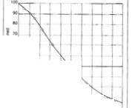

,II. .,

.... -

•bKb IDCIIU lbllt apprOAltQtlldy CNIC·

saufrom the la.fl('r slot situ that in­

«eatc lhc scr«n open arct.foru.anulc.

-.be. Ole . .,IC'f u U1C'1'11Slla&- *loQett itt·*

\'KC lJt(: CID bt t'.\pcccC'd before- ptu_aj"'

U«s the "''til yH:W. *l..attl-"t*llol siteAnd

OJIC-0 are! ptrmit the de·elopmcn t or I

*' j* ll!llldL.

flt•rt I,J.$. A 0.0..0. to Oh5J.Ia{l.t• .. I.S..M)

'"" oni ttl'ulfc:t.cl frOitl tllhP•'-·t:iu-4iur•l

•t••r&rl"o"llf.'.l.f'._ •.... .d.u,,y,.., .. . .,".. •114t

*,; :H:::to.50,! 1;;;._·,·''*

*: !!i!!. 'i:f;.o )\;•.' .:.::;.•* . '

de!tcrmincd. CiOOd de i&l'l C'alb for$U\'C'"·

•t& of tbt to"''C'r 6S n of the fonnauot.

llUrd of the aqu•f'Cr •ill bt KTttncd. To evalute tbe -'Uu.alion, Uetth the $1r;lt j,. lfll>hic «don •td rt(Ord 11Inform•·

thkktr.more permoubUlon!:arc: undtbt

..-.

du·, tk

tt.lt ..m "'

1ton ia a

cklian table (F" Jvrc 13.8 and

.,..

-..1

M'lftll. Tlus emuafty ifttft'Ut$ tht lpt­

e1rac « oty or the •YIJ.m.ak•na the' .,·ell moefficient and th.:R"ro"' tess ex:pcn vc

10 orx:r.ne.

NonhomotenC'Ous formauon.s attn mo"commonly b«:ausc Lhr ilrt:llJ.tb or the

bttt. ftSPO" blc for erowoo aftd deJo$1t10ft of canh .uttNJ.s tcftd 10 , ...,.O'U td·

•••vdtshortpcriocb ofume. \\"heft daiplq t«ttt'tSbtIOrmatioM.. .t1oc opminp

ror d1IT lt(1ton.s or tile "'ell Krten my bt: cbown attOtdin& to the andation of

m:ueri11Js in the d•AC:rcnt lt)'tfS, if th: lti)'tn are at kut 4 f\ (1.2 m) thkk and thtfr

depths have been det.ennint!d Cturat.."i),' Two additionalrtCOm.mendtlhons $bou.Jd be

TaWt 13.11).Sloe .tilts for llla'ttlllto bt

\11Cd ift a fOtlftiiJOD of OI'IJ)' C'trrOlaycn Clft

be $CIC:CtC'd rt:n dil y withOUII Ck&ip llb)C'

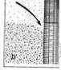

'n'lt tabk is eA t rcmel y UM'M, ho.,'C'vcr, for tompamqala.rse r umbtf ofsampletr.. Tbc depQ and tllld-...e:M ofeae• ta)'tt',

;\ )

for lO-. 4()., and JO.petetnt-rettinsbtt of r:acb sample, are re«>rded. The h)'• draulic eonduttivit)' can lhtn be esti•

....w.....-....w-.a....r.._.,.....,

)>

llm

-0

"0 0

"0 (0 (J) ::J Sl<> ;u

foltowtd.. bowe\U, •ilea tckau::IJ s1ct liP for a mWUpk-sloc ""-"=

1.ltG...c ...,.,..ovut""_rw_,.na ,._,..-*"'* .... J, J A (n• n)hfd eKftotft

dt1•&ned for the fine m:atenal into tk co.rse la)<tr below.

2. If fine material O\'tiiies coarse: mat erial, the .slot aile for the 5er«n Stttion io· m.lltd in tbe coarse la)nJ n (0.9 n) bcneath tbe formation conue uld oot be IIJOf'C thaA cto.bk the sloe '"l't fOr t.k O\Trtf1111 &ncr ""tcnal.Doublina of the dol

s.zc sboWd be doi'IC' ovn- KttU itlntJI\ent.t of 2 ft (0.6 m) or more.

A pphtion ofthe:se t101'0 ruomrn<ndationl trdurcs thci)C)Mibllity Ihat lbc"''cil may

pyrnp sand if the !cation or tach layef has 1.01 been detern1ined a«uf11td)' or if the

samples arc 1101 rdiabk. The &\li<k for skn-size scJ«tton indic:aU:s that abou.t *60*

t oftk formation lnlknal owtlloc K1ttft •"'ill *comt* '"toqlt a-.c: tC'TeCDdati•

1M ckvdopmc"t procus. Removal of tll1s frxtioo m11lu in somor tctlltmtflt of

matorrial aro1.1nd tile Kr«n. Thus.',he posnton of the o.,.trl yina liMf la)'tt movu d.oV'nward s.lia,btly as &eulina occ:ui"L

fi&:urt I3.6 allus;tralt'l 'Il'lhat c:aa blpp('ft i_f lbc first o(the abo"-e rtCOft'l.mtl'ldatioas tt 001 (oUo.,'tCl, Here the wcti!N oftx tefft•1.U. opc•utp sdtc1td 10 fit tht *CCI.nt't* uad bqjnsat the bovn<brybct.,.'C'enlhe t·wo la)"t'rs. As tM 6ncr fntC'Uon oftcoarsct material is rcniOYcd durin.A ck:velo :mt nt, llumpi.n& of the overlyina 1\nt•S&tld llytf may occur. Thi1ea n easily permit the top t«tion or tbc tcrctn. wbkh has the l r

U A cn. ._ . .. _,,... . ., .,_ .

, ,.......,. .,.......,......,....,...c.....,.,.,..

tt tllot all""'-'"*·

Theile 'bould be Yalues t.b1t ld be COD· sickttd for •K'rttft ia each i.,._ttd la)U wttbout coraidcruqt.M othn ll)·rn.

If a 65- ft Krecn• is in nailed in the

IO 'Cr pan of the aquifer, the tOP or *tbc*

.tencn is.a.t JSO ft. A*\·cncc* wa ter qr.aality

alld dn'dopmc:•t C'Widitiocn aK IUWMd

10 t1':11s cum.pk, so the cksip Is bo.xd oa

slot tlus Utat retain 4() pem:nt of thor: ma­

terl.•l.Scl«tion *or* the lot opcninas be·

PO l II lbe top or tht teree•. In lhis *a·*

••plr.*tbt* mcoul)ifteju,_ ·350

•M<Kt contl ·tiOI kl'tlrlt$ &ff: It ln knclll'

•>.., "'v'

or 10ft (6.1 aw 11111<' . *-r* dot

...'r'hek •an aum bk4 _. lht well tii

!If u.dnlliftlCIGIIIIrW'Iof.

IIU.ud ftOfll the C'UnU i• F'tp# ll•.t.A

f'tJllt of slot suu, abovc aod below lhc

-

40-JI('rttnl sitc. is t.llrn determined.

"d 1111111

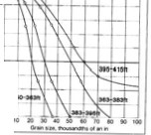

•

It:"i

t:..G-,!-

•..-•,

-·

n,,.,, *13.1.*Crd.•'-"4"-r"-kHI <11rou rttno

l<fllt'-11M.-.,... l:aytl'• t. • •li•IUief ....

!]_

-iil

3

"' '"

r.O

::I to

4.11 <.1li'JI "tu ...n•uJ.>

ft CM bt mat.d b) I tltttn ..,,,0..0...'0-

1 tleu., t .l lt..oY'ttt)U'IC ts

ha•dM: WlrM we 4nMilluhoo as ...._

,. ., ·' ...l$0 ..Jtl ft. n....the •

- -.•. - -•

.,

...4TU.•llJ.. "'' 4)9

PIICltd •-db.. tbt zoot tmmcd.atdy 1t0und tile "''dl scm:a u nude more pcrmabk by rcmov•aa somt rotm1ho• matntl and ncil...-ith snyCt2dcd material. Thi.l rda hvdy 1hu1 ZOIK tcpr;antn the- t«'fffll from tllc (OI'!Ution makrial aM i•

acaJa ti'K effect•"< hydraulic d&amctu ofthc wdl A filttt J)IC:t ilchOKn to rtta1n

.terta MC'tiOII for the uppn lllft' illOuld - , 1



....

mosc *or*the rormlhOft material• W'f.U sc:rttn Ollt'ftinc is tbt1!. sdtttc:d tO ttUial 'lJ

lht 111\1 l.t)Ct, 0.060tA

.. ....

sc:tttn.. Mtnt commercial filler pach ba,·e- uniformity cocfft<icnts of approximJ tcl y

h 'f C 0 020.•• •lOt OptftlftJS. tile raul • r

-

Ll)f'f, *0* OSO ••· the ""'' II)Ct, O.OJO 1n. *w:=-* '010 "

> -

-

*90* perttnt *or* tbe filter paek tl\cr cSr.vclo_pme-u Fih« pa.c_t mate-riall sbould be wtU

cooct

sontd tO !U$urc

I)OI'Oj1ty and

hydraulic

condl.lctivi ty or 1he mat«ial1 notar lhot

Appl)'lftl t.lilc nm m:ommend.ahOn,

llw f'int:r CIP'AI•l'ror tht top Krttn f«•

110ft t)S0 I O .)6) ft) midi C\IC I\d II k: "

...;.!.·... ... ..

.... ••

l. I n ct ltBin tttlll, bo 'C\'C1, (&Iter cb with u n.iform ity cocfficic:nts of • to S are

used occa,ionally wi t11 sood rcju l u,

f'il tc:r pllekil\& i.J U(l«ially ld\'tlnlB&fOU.S ·he-n 1he sed imen ts a.rc bia)ll y umform

) fi anto the rlytq c·01.nn mat tnal

:r:.: ..

...

and

fine a.rai ned. hen the Kdimcnu. arc hi,bly lami nated.or ·htn all the materia ls

Ttu'l J)\lll tht kforo'C't llm11 of the s«tion

•1U11 0020-la .. OPfll.l.fC' II )66f\. Ap.

pt.aa.on ol*tk* tteoDCl rc<omft'IC'IIIIbt.on

t: thSaUt IdCw'Qdrlobte DO

--- 10000 ,.,..... U4 .. )61

*"

fl fro..)61..Jl) ft. tlol M«lplft

,-...,., u. ·W'dallltd t an. c

...... fi.- J.t,) \0 JtS ft IS fiMt ud

..Y.C • 0 OJO.•• slot. .£"-eft

C-.V rt.. ,,

- ·- "

-

..

..

to be uttd in the 'A'CII conwuction m\nt be on site bdodrillinc btli ns.A filter paock

is aiJO advantl&C'OUI ""hf-R lhe fmiU olot .size dictattd by na tural <k\•elop ne-n t ltmltl the trltltmillin& CI.PKI I)' O( the liCI'ttrl so that tbc desired )'ield e&l'ltlOt be obtain.e-d. Milt't.IO\'eJ, tbc usc ofctr1.1in dnllinc n,p may roquithe insr1. Uatioe of•filt« pt e-t.

for eumpk. vnw r04at')' nas "'"" rardy complete a borebok &Nit is bs d on l.t

to 16 iJ'lChn: (lS610 406 mM) l11 diameter.Thu o.&be bordlokdiamcter maybe ml.ldl

tbaa ftquu't'd for the a Uatioo *of* a acreaa.

Sometft'lt'OIIImeftU "'IIJC:b fihtt pkb thould be- <:OIISi&rrd. iftdudc

tiiC""''"

*Fi•. l4ltlllf W.* o/ltrrW *•ttd flt'tlhmt (wtltill b/(1111171} lllflllfml* ••

fii

....... tht p• wt ll«omtt latan It

)tS tt. J ft. olO.OJ0.4.o.tlot .K'1'CU t U­

oo...t *rot ,.,*,. )911\. Ffom >91 oo 41s 1

these rc.nnation1., fiJtC'f Pl (. lbc COtUidntd to lbat latin sloe ...... catl

be USotd tO f antc thor b)'4twbc' di"KI(ft()' o( lhc 'ftdl Ia Stocral. if a sloe opt:flUIC

based oa ururaldc\c.lopm.crn.,smalkr tbaD 0.010 ia (O.lS mm). filkf pactu11mJ)'

=0

-u o

*c* ro

3 !ll.

00 a .,pktC'd ldfr<1.101'1 o(!Cn:tft optftlftCJ IS ..........,..,. ,..,..........-...

to suppty the doiyl<ld. I *r*tbe water ia ca:tremcly iDc;:n&SCiDJ, a lower bmjt *o(*0.0I s

""'

ft.. tlc ktft• Mt I 0060-tA tiOI tot.& 1llc

.-..-.1n *r-.-n* IJ,I

If a«UfilM tampks tom luw••ckpth.s

,.._ ,.U.t_,Sir-.,.......,.. wc.._..,.•.., ..

(·) .r - .... ·t.t . . ..._

... .,.'" . ... .

be moin.blc bcavthe ICrecA'a \nntmJttiqcapacity may DOl be pt:at mc>Qf,h

i n: (0.31mm) or 0.020 In (0.,1 mm) may be u.scd i.oste-;ad ofO.OIO. Some devtadon

from lhis U m it ia pouibk. U!u.ally dcJ)Cndina on lhe mineral QOO tent or the: ..IC'f.

(/) ::J

S<l> ;:o

Itt ev1llabk. the wtll lkllaMt iMou.ld Ct.l!IOm de,.. the tcreta to fh 1M aquilit eood•tlons at the well a;,w.b«aii$C11cosu 1110 more to •tc • multaple-sloc tc'fftft,U.w: of 1M propct llffttn opr11inp to fit ei<:h Kdime-ni iJ )'<T "'ill http Kblevttbe hl&btll poM.ble ,pct nc c1pa,chy and _.ill arcatly rtGuce the pou•tKihy o(PIIMPI-a totnd whh

the ""•tc.r.

t' Utrr Pack Dnl1•

Tile t«oed .,nm...,. IM:Ihod S. C'On'l.plc\lQa wclh ts by fihn fll(.,lflt. 1.• nlttr•

1"•...1),11.Dtt;ip T•Wr r.5cnnt S*ot Sl.

,...._ l - tlo) '

For uampk.in some arus of the Oui(Coulal Plain oftbe southern U nited S111cs. Baturally dev lope-d 'A'Cib ·ith J«te.n OJ)Ctlinp as smoU as 0.006 in (0, I ' mm) are used because cxpc-rie- n« has 5hown t his to be the best desi.a,n.

I n other sil v11ion o, Rit er pad:d«illl 1.$ dictated by the ph)-s:ieal na ture ofthe aqu ifer. In oenain linc-sraincd,unirorm.l y 10r1cd fonnations, a naturally devdoped ...',t-Il may ltad itbtt tO 'ow )'iclds bc-Nuse Mlrttn slot sizes mu.s-1 be rc:duccd, *or* to hlf,h rates of und pu.mpina. filtu packina of tbcK ume -·ello ""-oukl generally kad to bi,ahc.r an:d·ftte )iclds.

Wm,pks of ftne"'f''iMd fotmatton:s In "'flieb wdh *a.tt* ordinarily fill« pacbd

iDCIV<k tbc Tcn&al)' .a.ftds oftbt Oulr Coastal Pb.ithe Opllala Fonnatioa i.n: Wen

Louisiaru; aDd aqu:iftn *o(*1hc lnctus Plauu ia West h1:iSWl.

= ·

oro '"3

"' '"

- ·::J

::JV J

*"itt*

......_.

, T1. '-t!Q1 ""'....., Jl'

*$t·nutollldidall'tl (ftiobl»ftbtOM.* ).{uy prochK't·i,e saadstooe- aqviftn art:

)l0-.16)

"I") )00 6,SOO

0..019

OlO 0.014

poorly ttiiKftted.. The Ol.to&a Saach1ooe ia Nonh llld Soutlt Datou. lhe Jotdaa

.16).)1) JO 1.000 40.000 0.04J G.OlO oou

SudJIOGC i• some &JUS *o(* Ml•DC"'CM&. IJIId tk Gatbtt ud Elt Oty Saactnotwi i1t

:JU.)9S 12

.19 1l JO

1.000 12.000 Q.026 Q.O)O 0.0)4

l.lOO .10,000 o.cm 0.060 *0.010*

hole in thcx IQI.Itfc_n. 10mc: sud pathe:ks eoftliaualty slooP &om lht nih of the holt, multi"' •n 1 .talld·pt;m,plftl•cu.The .,.iQI may tqin imrnc:diatd)' atkr

r,_......,,, II.SOO

lhr wdlls c:ornplctcd Of after tcvtnl monthshave tb.pscd.dq:lcndiq on lhr pumpil!ll

..., ,_AlU4''1>-..tus

..,AlUI"'

...

rataod tk a.mo•cn ol«mt:et lto&dao, tht SIJid CRiDS 1otf1her. lk h!lkf tk pu:mPint rate-, tJw lnOft quiC'k.,.lloucluftC •illbqitL Tk pottflli.al for u.ad. ,._. swompu mu) •dl-da.tp C:OIIftotfl'S 10 st a .-d scrtto.Bttau.se most sands10

arc fine ara•Md. wncn •e•np or 0.010 io (0.2S mm). Of smalkf, may be rtqlolirtd

to aercen tl'ltm corftctly as naturally ckvt:loptd •--c:Us (bued on SO-pnce1U f'tlt.fttiOft).

Even Krtcnil\l tt the .SO.pe.rtent r«cntion levd may requi re 1 Ions de\·elopment lime, tnd larse •mo\lnU ohcdiment maytuve tobe removed from lu"04.1nd t he Kr«R, For such fonnahons. t hoertfon: 11 is aocxl d<:si111 practi« t o u.$C sfl(daUy Vlded filter p&cks so th:u lllt&.c:rnrccn on inatean be U$Cd. I t is important to t«()IIUJC, hOwever. that the i nntlllllliOn Of fl filler pa(k and Kf"((f'l USU:t il)' fl:ductS the $pedfic: Oll l>leil y nf a pre\•lou$1)' opcn··holc "•' cU. Nc,·c:rlhele$S.. the rcd u<tion in yield i1prefcnble to an un.endina mainu:n.an« pr<lbkm treated by $and pu mpin£.

Anot l\rr rc:uon for filt er l:in1a sand-stone aq uirer ilthat the (Ornuuion material utually providc:s liule Or no btcral support (or the &rree-n. Aho.the (ormation d06 not tr:ldily th1mp QliiiJt the Krffn duridevelopment, in contra." to vntoniOII· datKdime.nta. An.er Kttina the Kreen io the open borehole. some void spaca remaia b«wecn tbe Kn'C'n an4 the borebole • U. It is pombk that a t«lbOn of' tbe

formation t0t ld bfuk otr.faU apintt \be sereea.aDd cautt dam.._ Loote. vaoular

matnlftttod ·ue the t('rttn and tk bord.tok ....u IIC'C'JOCII.modatcs ittd(to

d tile am:pbnhet otthe bottholtb. otb the ...U and thr tttml.

tI ).9 abo-.'t lM coulniCtioa de­

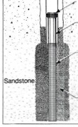

uib of a filkt•paoclteel WC'II filll.slaed 1a trmi«''•IOI:tdatcd aocb&oac' T1w latttef Jpracir arouad tlilc ICTtta 11CTU\cd by an

The padt.oa of dtt rihn pad .,_W be butd oo lk craill siM of lM fit at la)'ft to bt SCTttrtcd.. A filr p.wl. wkfltd ,,. that munnordiAa.rity don ao1 m1nn tht Dow £rom tLl)m *o(* C'Olttonl m.aknal Tille b)draufte COl'ldiiCtivity *o(* tPKk tS teft.<eraUy several umc:s &":Iter thu that or the: coars«t la)·en bcavse the ,.,:It " de.1ncr a.nd more o m(orm.

fihc., k matcnal 1llouldeon.nst of duo. wc:ll·rovndcd &r. ins or a o n•form lltc. Thes;e ch.aractttistict incrn5e the l)ermeatnlity and pOrO$lt or the: pad: matcri.al, Pit• run or crushed mat nab; fire u oall y not Wt i.s(a .:tory for lilter pack$. The ehtmi('al na.tu re of the: fllter pack ls 111 l mf)l)nan t as Its ph)'S.ieal ctlaraet eriMics. Fihct padt material can.sistint n1a tl)'or ,ihcrous, t;1t hcr than (lllc:a reous, partieles is prdc:md. U p to *5* pc:r«nt catcar us mat erial!,a cvmmon l'IIIO...-. abfc limit. Th ii1i mporlllnl becaust at-id ucatmt:nt oft l ot Y.ell •nit)lt bl.·1'\"ql.nrtd later.snd most of the add rould be spent in dissolvlnJ tD IC'•rtO\Il parhdcs o(U)( filter pad nuhet than in tt'movlna incrustina depot.itl otcaiCtum or uon. Sim1lanly, if the gound,.'8ter is sliptly .eid1c. pa_nial diuolution of the pack m.y o« or O\'tr time. Particks of s.hale.. atlhydrito,•ttd J)'pt;um ie the fl.lter ptek tnltcnal abo •re o.ndesu'lbk. Tabk I).121imtht d«irable pbys)cal altd dl tmleal dut'IClc:mhCS for a 6Jter P*Ck and tbe advantqc:s of 1.1.d11J *lbt:st:* mattriak.

The sttpoutb.Md bdow ate (oltowtd 10 dts.icai_, .a fihtt pact:

1. Otoose 1oM b)Yn •o bt K"ttC:Md ud cooslnK1 - aaf'·es for 1kle forma.UODS. Sdea tk arM•at of lK tiJk't PKt OD lK bam of the:1K''e aaai)'SiJ Aw lhe ta)-n offiant matmal. f"'l:llte 1).10 s.l'ilo'lll,cJx lf*b•ot••-o umples oft)'Jikal

•'lll ·bnrinc 1naterial ftom a• v•ftr lO t't (9.1 m) thidt. Tlw fiDeJt matnial lw;

kt,..«n 7S and 90 t't (22.9 aad 27,4 m). Tbe deslp. ohhe fll1tt praoct ia this enmpk

)>

rvm

= 0

-oo

<= rv

3 !!!.

-"'

\0

ui'ld«fta.111C'r thai •Mtr:atO tile bonhok dJa.mttt:t only •bere ttquirtd. Tbe over• sind borehole provl<kt J\lffidcattnnv-­ lor aua *(ot* a filtt:r Pltk.

*Ext tuivrly ltll"lftQttd formatlonJ.*

·r.it.

••/ BCwOI'IOit

*r··*

IIbt based on this byn. In tome •Mta.nft$..ilis J.OOd ptiC'tia: to ipO« uofa...onbk

ponioM of aa IIQU&(t:r a!MJ to UJe blaok pipe: bctWttl'l S«Cions of Kf'«ft J)OSltloM<I

in tbe more pc:nnc:ablc t10R1of tbt aquifer.

*2.* M ulti ply the 70-pcrccnt tlu ottht ediment by a ttor bc:tw"Citn 4 D-nd 10, Use

4 to 6 as tbc multipli-er ir tbc ronn.1tion i1uni(ono 11nd tbe 4().pcrecn t•rtlli notd t.i e

"0 co

<I> ::J

S10 ;u

roc

=

Some aq uiren contbt or 11hema ti n, thin la)'en or OM, mtdium, a nd coarse scdi· me nt. E.. mpln lnc:ludt the Maaoth y Formation ofLona hla.*New* York;the

all uvial ckposiiJ ofthe San Joa,cau in Val• ley orc-nrornia;the Santa Fe Fomut.iort of t.en tral New Muico:some coastal

plain deposilt of North Carolioa:the Opl.lat.a FormatM)ft oftbc:H.i&b Plains Jion; aad tome hiJj!Jy lrallr.ed J)acu.J aquikn. It i.S. onu dltralt 10 <kttrmine Pft'('itdy llrtt f'OtitJOD aDd thKbess of c:ut. iDdividu.atla)w bd tock-wp•mul­ tipk-s&ot KT«• COfrupondi.D.I to Ilk>

$tf11tiracioa. nc:rc(orc.fi.her pac:ltiq

. .ould be tP«•ficd for ...ells ia th«<

typa or formahOM to avotd scrttn: p&acc- .

A.­

.Pfc:tl«

.Rlto< ....

WtJ IOI't>lft

,-.,.,.....

._ w...... -r -•• =· ­

T1blr 131.1. Ot& lultl'F'llltr l'adt Characttrktlc:s ud Dnl.-td Ad"'nt•l" Chlra.cttrl tle Ad vantsst

Oc:an Unle lou of materia.! durina de,lopmtnl

Ltss development time

Well-rounded sra•n• H'lheJ h)'draulie ocmchtetivity a.nd porosity

JtodiM:td d.t1.• 'll

HoaJ><r )Vld

Mew dl«th-e ck''dopmc:nl

90 to 9quaru: craiat No kiM ol''Ohune c:amed by diissolulioa of

"""'""

Ullif<wmuy eoc:ft"idoento ( S or kM t.os sq anhoo duriz:c itiSUibtioo

0co 3

c-"o'· ':":J

::J <n

ment ptOblc:mt.

.,.lllif.rn ndl• t cllilol O..liMa ...LA\. s.....

,...,..s-o o.uca.

Lo•n M:ad Joss lhtotl&h fl11t1pad

AED Design R equirem ents

Well Pumps & Well Design

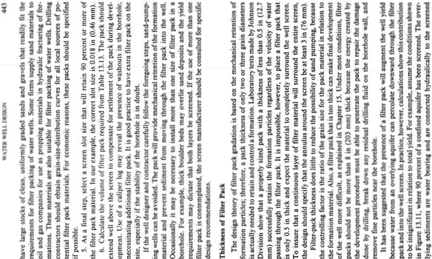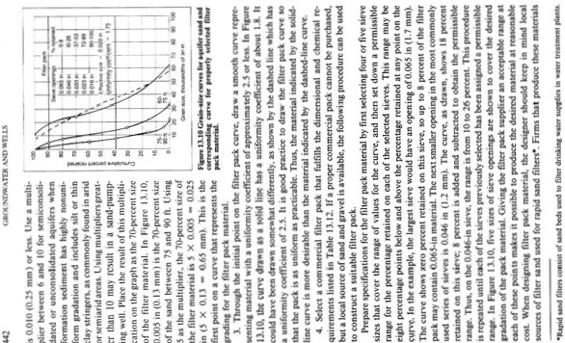

50

... (;ltOIINl)\\ATl:R ANI) V.'\:U$

ponion of the ""'tilby Ibe 6-in (I 52-mm) fih('t pack. Tht theor<:tkal \'Oiume of *""'ate.r*

*Q - KIA*

lS II !:l "' 0 -

;at.

by the Ducy rquru.iol'l:

f ,.

6

, , -.

;;: "'

Q • [ :i

*Q* • vertkal Oow through the pack m:utrial. i n &pel

0 2 0 0 0 '

*#:* ... hydravlk conductivit)'of filter pack. in cP<Vn:

*I* - h)·dr;• ulk a.r< ilienl cau$in1V<'rtic.al flow in tht' filttt pack

"'

'" ... ';

- ••

- 0 0 0

;o 0 0

·

I n thi.s eumple,thc :lV:Iilabk hc:u,J is 30 n-the difY.rcnce lx'twccn the pumping

*level* in th(' well and the S.Uitic water kvcl in the upper :IC)uifer. The averill(' d iSlaooe. Utrough o•hu:h the u pper wtlltr mu$1 move is about :i'tl ft. the distance from the midpoi n t of the uu:1cr aquife.r tO the top por1ion of the scrcc.n. I n this *cosc.I* • JO/

28 • 1.1 and *A* • 2.25 ft l. *The* hydraulic c<>ndU(th·ity, *K.*oflbe filler pad; must

be estimated. A reasonable upper limit for pack. mau ritls i,s 1 7.000 iP<I/fV.

!..

I..

'; , , , , , s

*<!* , s,:s: , ·

,

=

.. , , ,

The amount of "''titer tr.nsmi tted vertically in this c::umpk i10, therefore:

*Q* - 1 7,000 ·1.1 • 2.:U - 42,07.5 gpd .. 29.2 gpm

f ' ; , ":0'

0 0-

,

I

.!:a:.;

'J ....

..

>

The contributiOIJ of *29.2* apm is a relatively smaiJ prcponion of the total amount

b)'dtaulic eortduttiV'ity of 1,000 spdfl\1,i u transmiuivi ty is abou t SO.OOO spdJn.An

!::: *8* a

'; ,

Q , ·.r

;:; 'DO

0 0

-

I

*effitittH* wdl in tl!is aquifr ibOuld de·

"' ";;';

"0' s I

;:;

3 !!!.

·dopa spedlkcapadtyofabout2S gpm/

-

Vl n of drawdown. A drawdown of 30 ft

'-., ntgrotJt

f "g:'

lt

f

- . -

1-

I"I'

0

I I !•?

-

-o

•• r

•..

V>::::J

would mean tl\at t!)e ylck'l or tbe *to' '<t*

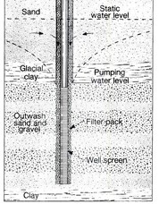

fonn.ation alone is about 750 apm, The

i::

•• '; E g "' I I

"0 (0

theoretical yield from vertical now in tbe

filter pack is 29.2 gpm, or about 4 pc:ra:nt of the total for tbe II.

i ,.

t: ;::

, I I I -..

roc

oro

The aetual contribution to tbe )'ield

0

,.. ,-

*N*

;;: jai

----

"' 3 •

.'

-·::::J

bowtbe pack is pla«d,how muc:bdrilli na

fluid remains in tbe bort'hole.and the physical a,nd ehemit;al ehan,e10 that take

"' "*N*' ";;';

I I I

aI!-.a..,. f , ••

;.

::::JV>

plact in the PQCic \·tr time. When the

lS 0

I I I I

;:,li'

unt\'en seu lemcru of the material c.an

('rf!'llll!' XOn<'f o(finCcJ P'ol"licii!'S inti!'NI)('Ned

..,·ith rser ml'l t eriJI. This byeringefT«t

"' 0 g I I I I •••

-·

e:n re4uce sisnir.unll)' the \'trtieal h)·· draulic conducti\·it )' of the pack. l'he rcmnanu of Cl#y :t«tith·C$ let\ ()\'Cf from

!:: 0*::.*

, ,

I I I I

.-..-,-

thedrilling fluid also an deerca$C the pc>­

prima rily around the scrtcn. and onl)'

tile«1•.ad:abo•,· 1Matada.lday -Ill not tollCriMk

IU IIy It> tbtybtd .t tiM •til.

..,

;;; I I I I i•••

§ I I I I I '!:0:

:5;·

, ,

"' s

I I I I I

'!?oa a

'1>1> N!>IS.:JO,U.\\ ll:lt·,v..

... C.R)l l)'oll'\11 1t .-!'OU'IIOL L'C 'A.' TUt "'1'U-OE$Ko!ll ..,

tmall •mounu of f nr m;teria l e:tn k removed from 1nite-r pad abo -e the t.'Tten, s,..,. '1\0tt imrw"1uu th¥1 the:w t""'O buors llfC the l)bni:al and themi>ea l ehfi i\&.C1 that o:c ur in thf: put of the pad O 'tr lime.Aeration oftllc filter pack o«u rs In the u pper aquifer o•bcr, pumpin& bqin.ad ntlaeralt in solution c;,1prte\M tat

"'IX''

and p!uc the filter !)lclc.. cau$in&a sipific-an t rrd'uc,on In the yidd. Th u., an •n•llal

• ·rK'-t'Cf.IU tolUibUiion totllc: tom) )'di 4i Cln becomr much len aflcr sorrc n'IOI'lhs or

)'C'II") 01 P'U111PIR&. In otbet SitlllliOIII. the' pci\'C'ti&IQ( ur 1.¥utull11lO.:.a rw.y ....,. bvl

''&!...,,,on) a maO pan oftl!t toul )'IC'kl.

ltil l

T1w <'OM M fihcr pd::u:tc a ""tl dtp.•ft1Cb 011 tht dnltlll mc'llod. *'t.t of*

«"'ct.pcK• ."-c 1M'o Uatio.rt. ,_.....,... *.-4 ....* a...-.hbd•lt *.,tr.t-on* m.a

'"'"' The luarr hok s;i:K rrq11ftd for • til'".,..d.srrxnllr u: tn<ft pu

*1004* "'""'" ti"''UI'l'l YJth U )' rit cdtet tl.lft 1t:'cne: rotary mxtu!IC'. Witb tablt tool

d rilhra cqutn t dO\Ib'C!$ of tht wdl d o wcur my more than doubtlht ctillioa cost.In d11o.:t rota;y drilti n:&. IS"J(·di.,c:ter ltolu 1lso <:Ol! mon.as a "Uk.b«'au.sc

more iscous drillinJ fluids aoo hitbtr dnllina nuu circulation rates 3l'e flttd to

rai1c the: culli nt't•> the srou nd su rrac:e. On fie other ha n4. wit h revtnc circula tion drillirc eq uipmenl. a n 1n:rtase 1n note cJi.a mtter boflltllt c.vncm1.D•iUi".J " J6-il•

(914•:n m) hole ctntrall yc:osts o:.l y a.ligbtl y monun a 24.in (610 mm)hole boc;ause

11..,.,, W•k ituu of ur.u. e;o'' an •

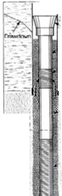

'

c.:an a.nttdpace U1c.r n«d,_ I n this SAIUI.t ton, llw: cost *of* the filler mllttri.alas a small

pa.n or the co-.1 "''<'II co.t.l.

Two dtsiln cnor8 lUll common in fil ttrp·ac:ktd w·ciiJ, FirJt, wmc: con traton. UK

the same pad; in til their ••tll.t. rtp.rdles.s of che pa rticu lar f()ot'mtdon. a pract.ioe that ea.n kad to low)'1tlds or pnd.pumping."'-ells.Second, t contr1c1or may o se the oorrect fil ter pack foJ a formation, but "'ill usc5Crctn from stock wilb t s.iUJ that an:

100 Jmall, ,o\p.UI.w ridd.t.·likely becaue of red\IN'd h)'draubc ei'f"tdcDC')·aDd a

IKY for Jnk• UKfll hc:m.

Cost compall.tonl btt•wn WC"Ib tbat an:fi1tn pad:«< afld tltoK that *art* aatu.ra.Dy na be *ma6t* Ont) b *{Jt* •db. ckptadl...0111 a numbtr of Canon. No su.ttrM1U no bema« that OM mnbod as mon: toitly Ott "'lll prod « l'llOtC" efi'Rnt .,.·dts than t1w ocher Both methoch ptOd ttt •"db that ha...c: h,P. speri:6c:

pai tin. 111M1 fkt.and 'lfrlll I3St mar&y )'f:at'S wtlbout cMt.n.t.l''f: mail'ltt::naott. PRESSU R E-RELIEF SCR E.ENS

In some "'ell iMlall liOn.l. thedra"'down out.$ide thewelt m1ybe •ianil'lta ntlyabove

tbt pumpins level i nside lbc QS.in;.ln theseclrcu mtanC"Cs, hlth presudifftttntials

ny cause a t>O"'t:rful U P"'rd now of water in the: fi hc."r pock. Occasionally, the

di!fenncc bet""un thc pressure in tbe casins and the ptcuurt ln 1hc bort.bok isveat )>

enou.P to lift off heavy tca4 shp f*kt:n, or to lift filter paek matcrl.al tp to the pump m m

la.rttrbit.a lu.,er nOO pit.and n.on= fi.l'.tr

Mll ltl

. . I

intalct if ftO packer it o d.T'.abt *01* hipl)' stntiried rormatiOM are most likdy to

kad to h4h dJff t.al prtUu.To rt:tit::'t'C prnsure ll'llbc: (•her pact. a lbon pres­

= 0

1JO

*l.h*

N

Foe tttU.i'o llifam a;eti.mmu, lhc:W5t

for AUU.ral dc:'t'Ciqlmtat of a •-dl may o.m::d lk o.tn asu for lktMft..

hok 1.-d (i(Ur pa:k ttq>Ure4 *fot* fiiL-r·

.-eked wcllt.. ha ..UM tb£: driD:tf

coati"K10t wiU dwJe approxi ma.ttJy SO

,.,.._., *o(* lhe driJiq: nte *(t;or* IW't'l

mcn t b«..use the ria b 'till irwol vin

t be vclopment prott$$ altbolah lh:te

•rc n) bh or casi n& c:Otts.It is sometimes

morccc:oncmical, thtn=forc:, townstrJc:t

1filttt•Plf,C:c:d wei beeaust theP't'intl n dc:Yclopmc•t timt may off&et the ('JUI lnlllll eo...Thb io c:VQU..ny uuc ir ,...

ta(le •ndall•vial ckposjts1ikt those f<M.nd

.,, OU....On.a.. .n'l. to'Wi Ndrw;u;;b.

I•lOme U'QS*d* tilt ....td., iJtn pi('t rulcnab 1ft 001. tt:adity avdabk *tnd* mVJ.I be tf'l.lsi)OtUd ltuJtJ:tcc;h of miln10 llle 4-ll.hq Ill:. fkwbne, lljp..andrfil­

CC'f' PKb *art* avalable .uy al)d cos:t

rc:la1 vely ht tle.hoyd rillina c." tntrac:10fS

•ill ",....'- ao 01' 11t0f'C ofilter p.ck

11 chclr plac."e of busiotss bc.'ca uK clley dnll rn.ntin r•• ll y lathe umeaoui(trs JI\d

L:.eed., -·. i

;i: - -

*.=.* -=-----

/ Ftif!r pack

.rW-

J

L

nrwt u.1 a. A ,...,...._..,'"-....w 11t

haiW J'"'"' '""'..., '*or tiM't'l•lrrtl tt

lftlt'••l•l.t tllf n lal'r""""' ·

*su.re-.rdid* iC'JUtl s.hoiltd be 1ascaJkd iD the risc:r ptpc liO lhl II II JU)I UP iiLiide tbe

bouom o( tM Q.a..(Fiprc: U. U). O.riac pumpn&. PfUIW"e dltf'trutiah Ill' reo

·ed throuP dw wn:ea ntkf thul "P 1hrou&h tlllt pratt. h•tlood cblp

to •nsull a prmutt::-rchd KTttD kl•tta W t09 of tbt PfOd\IICiioD tutttud tbt

lOP of the rivr ptpr tothm•nalc the build-upof diJT nual ptt::t.t;lltU duriQJ pumpiq. fORMAnON STABILIZER

The pri mary pu rpcm of a formation sLabilittr is 10 kcc:p the botcbole OI)C:tl ud

pre·e nt C;t...ina of overl)'ina daY$ Or other fi n(' materi:l i n to the serccntd portion of tht well. In u ns·•ablc rormadons. a stabilizer s.hould be coMI<kffi.l if 1he borehole is mothan 2 in ($1 mm) laraer than tbt asina or taccn, For cu mpk. io Soutb Oako1a, ser«nlih$10M formations arc often pa.ekcd with l b.ili.r.u materials to pte't(' 'tU lbe pumpina of s.lly llo'lttt. Stabilizer'$ a.re also lolled 10 preven t premature c:aof formatiOn makriaJ prior to ck''eloprMnL This can be 1 Of probltm i.n

·c:rsucd bort'hln Of · coafialf!& prtUUrtS Iff prt:K'ft&. b«autt c:avaftCOfb4bJy stratifKd. rnatn'lollh ('aO C'l\l..llt ifaeut LO tht porotil)' t.ftd ptr1DeabiJiiY of aquifer m&ltnab for tOmt da...,.from tht boft:llolc.A SoeC'OOd fimc.tioa of

the: subduCT mncnal tt to lftllftlUD or aU&mCnt tht: hydl"'t bc co.d.vctavhy *o(* tht

natvral formauoo.

Tbe I)'Pt *o(* $tlbll•ter 1.1toed ckpeodson the pbysicaJ cbar.cltrbtft:s oftbc t'orm.atioa

mtenals.. FOf completely unconsoli«Jat.ed fc>rm.a doft.s tudl "a.lluvial onds aod sil ts., or aJ,aeialunds tnd ,,...,cis.tbe sUr\XIizer shOuld bt tbOKtl whh cart.Beea u.se the we-ll h t o be n111urally de,·c:lopcd.thc 40-rttn t-rtl.aintd si1t: d"'tatcs tht tctttn slot Nz.e. nt.e s.Labili:c:t ;, then <ho5en so I ha t iu aradtd sir.« art sim ilar to Of slig.dy

!:user than the natu ral formation. I n practitt, the median train abe (SO-pcrct:nt·

<::m

3!e.

'0 (0

<n:>

llO;o

m'€"'

=ii"

ai'3

!,!?.

<§t;;

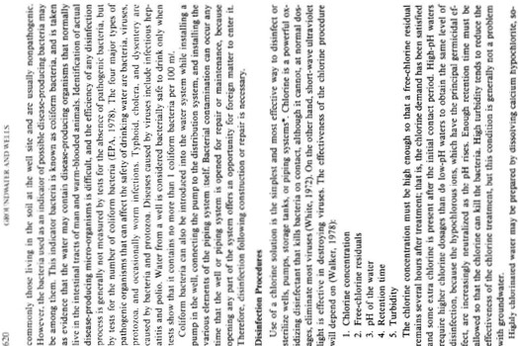

.. ·-.: >- :;..v=E:2t



r·S;-"i! o ":-,lic- 31-; : c:e !H4 -.II

:q2e•¥1-; r... :i i"•-z Jl

a ... · j

...

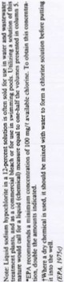

=-

8oo.o...-..;o.o.:r-H.•..•.."o"t '

l•li

t"•C C.

'0 ... ·-

= ... p'"S' ·t ;:1J1a

a j :v

j · v.O!i¥

.

;;

N0.2 i= !

N

t-;;C: -.e.c•-s-:! '15""'

a. ;; ...I -:]-5j Et S :§,..

t: i

i d 1!

a ! i!..- ·

'""

..,.

eeirtr" e i J

• ..c) ...

g!!'cst: _ ,1;_2 01:

l! '1!.

i5 • -""-o..o-N:,l:-o*...:*

o!l

!

*-=*t 2.5g*A*.. *ll* )

£ 'o c c 5 -

*§* p.•

....

t1! .l> i "l.'.:•;;.'" g "' · lJ"6 1 *It* r

*-;* c:iN•= :S;'Q

p- .S :·" 9--

e

5

j

,-e"•"v"•' "e'.§,.e »g .i.!,i . » § !

·j... -\_o.;,.o.....=;.._,.;..;.:.;. ,

g ,.w .c ih]B

, s§"!! -.2·-!i<Se e.

=Jf

,.._ CIO ,_-

-= lei·"a

· ·-e· :ii e i!

. 'S

$ i d ....

- -N

# ' N

# c:i

• '-G-,... ...

• g ';(:c c. O *c.* aoJi a g,!i

·

J.l

i • g S: .... NqNO>

I t;_ g--ee GJ -

oooo-.... ... "

Hh:;:o- o .c<> en *;i* & &- 1!

¥ ''€- *e eg .; :;* !t *:r* j&J ie• 3

! - ""! ;:}

--· t;.! §-ct . ru·p

>" :. "'"' - : : st

rl • .... 2S2

-e:$•=e t.!::le"'£•15

;

.: . •

.: i1*.* ; ,; ''! z .sS@ !

..j

:! 2 _)

i 'o t:&] J;t=K5 e

HHU

"" .! N .. \0 00 ::



**""'<00>-**

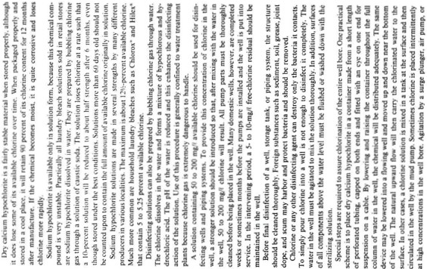

.

j

!

t

tl

**dOt' """**

, Jr "" ........ ¥

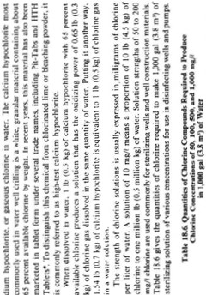

: **d .O !:!** !

•

*1*- ;

a l ·:

il **f** "1

"-, **....oq** Ie



IP 1 •

**00-iw**

t

-

i

I

•l!

§s.•

r· r J

- **:::::<**-**;l:::** *A*

**.... ooo**

1**g..:.ng**

-**Ii** ·

i'" I 1

: **00:"':**

**f"'' ...** ...........

•

• ..

ui t j

.. **0000**

:::

' -•• ,;!lil

< i **1**

-

1n H t

**.....NO**

**·-4-"-c'1!:.0!**

(

... **....... f"''**

ii ;; J !

t

*h*

·-.-. • *l*

•

!

1**_..(** -**..-i**

*I•* h j I

**l**a**i** l .r. i!

J

Ii *I* s

. •

iiSl !;

H.. **i** i $

! I #

*J*

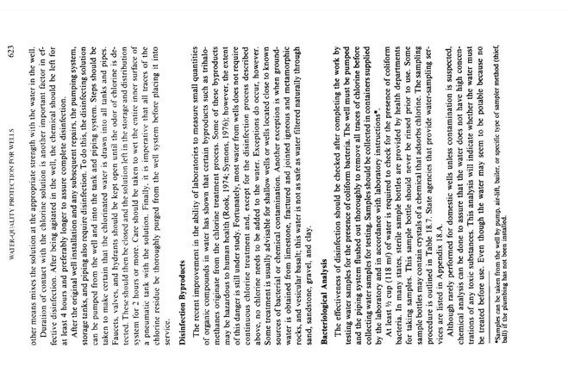

**APPENDIX E**

**INSTRUCTIONS – WATER WELL SUMMARY SHEET To be Included in the Final well Completion Report**

1. **PROJECT TITLE AND LOCATION** – Identify the type of ANP site or name of the

ANA/ANP site and its location by District and Province.

2. **DATE OF REPORT –** The month and year that well was completed.

2a. **CONTRACTOR NAME** – Provide the name of the prime contractor responsible for drilling the well.

3. **CONTRACT NO. –** Provide the AED contract number.

3a. **ELEVATION** *(Top of Hole) –* This is the ground elevation at the well site.

4. **COORDINATES –** The coordinates can be in any one of the standard formats (e.g. lat/long, MGRS or UTM).

4a. **TOTAL HOLE DEPTH** – The total hole depth should be in meters with an m (e.g.

120m).

5. **HOLE DIAMETER** – The diameter of the hole should be in millimeters with an mm.

5a. **STATIC WATER LEVEL** (*Depth*) **–** This is the depth of water in the well after it has come to equilibrium without pumping. It should be reported in meters with an m.

6. **DRILLING METHOD** (*Rotary, Percussion, Other*) – The drilling method for the majority of the hole.

7. **CASING DIAMETER & LENGTH(S) –** The casing diameter should be in millimeters with an mm and the length in meters with an m. The setting of the casing should be provided (e.g. 150mm, 0-90m).

8. **SCREEN DIAMETER & DEPTHS –** The diameter of the screen in mm and the depths of the screen(s) in meters. If more space is required provide the data in REMARKS.

8a. **SLOT SIZE –** Report in millimeters with an mm (e.g. 1mm). **CASING AND SCREEN MUST BE STEEL.**

9. **WELL DEVELOPMENT** *(Method*) – The method to develop the well (e.g. mechanical

surging).

10a. **SANITARY SEAL** (*Depth*) – The top and bottom depths in meters. Thickness must be at least 3 meters of bentonite..

10. **DEPTH OF FILTER PACK** – The depths from the ground surface to the top and bottom of the filter pack in meters (e.g. 46-57m). Must extend at least one meter above the top of screen.

11b. **PUMP DEPTH –** Provide the depth from the ground surface to the intake of the pump in meters with an m.

11. **PUMPING TEST** (*Yes, No*)

12a. **HOURS OF PUMPING** (*Pumping Test*) – Provide the longest continuous time of the pumping test(s).

12. **PUMPING WATER LEVEL** (*at Max. Drawdown*)—Provide the maximum depth to the water level in the well for the expected long-term pumping. This level is determined during the pumping test.

13a. **FLOW RATE** (*Pumping Test*) – Provide the flow rate (Q) associated with the

“PUMPING WATER LEVEL” of 13.

13. **AQUIFER MATERIALS** (*Unconsolidated, Porous Bedrock, Fractured Bedrock*)

14. **WATER QUALITY TESTED** (*Yes, No*)—This question is limited to an established water quality laboratory.

14a. **TOTAL DISSOLVED SOLIDS** – This value is provided by a water-quality

laboratory.

15. **COLIFORMS** (*Yes, No*), -- Are fecal or total coliforms present?

15a **PUMP** – If information is available, provide the manufacturer and model so that the same pump could be replaced in the future.

16. **NAME OF PREPARER** – Provide name of preparer and supply additional information in the REMARKS section.

17. **REMARKS:** Provide any additional relevant information such as contact information, title and association of preparer, distinguishing features of the well and/or the site etc. Provide additional information such as screen lengths that will not fit in the space above.

**WATER WELL SUMMARY SHEET**

1. **PROJECT TITLE AND LOCATION** …………………………………………………………………………………………………………….………………

2. **DATE OF COMPLETION**…………….……2a. **CONTRACTOR NAME** ………………………….…………………………………………………..

3. **CONTRACT NO.**……………….……………………………………………………………….3a. **ELEVATION** *(Top of Hole)..*...……..………….

4. **COORDINATES** …………………………………………………………………………...................4a. **TOTAL HOLE DEPTH** (*m*) …………….

5. **HOLE DIAMETER** ……………………………………....5a. **STATIC WATER LEVEL** (*Non-Pumping Depth*) ………………..…..………..

6. **DRILLING METHOD** (*Rotary, Percussion, Other*)…………………………………………………………………………………..…..…………….

7. **CASING DIAMETER & LENGTH(S)** ………………………………………………………………………………………….………………………………

8. **SCREEN DIAMETER & DEPTH(S)**……………………………………………………………….………8a. **SLOT SIZE**………………………………

9. **WELL DEVELOPMENT** (*Method*)……………………………………………9a. **SANITARY SEAL** (*Depth*)……………………..…..……….

10. **FILTER PACK** (*Yes, No*) ……………10a. **DEPTHS OF FILTER PACK** ………..…………10b. **PUMP DEPTH**…………….….…………..

11. **PUMPING TEST** (*Yes, No*) ………………………………….11a. **HOURS OF PUMPING** (*Pumping Test*)…………..…………….........

12. **PUMPING WATER LEVEL** (*at Max. Drawdown*)………………………….12a. **FLOW RATE** (*Pumping Test*) ……………..………..

13. **AQUIFER MATERIALS** (*Unconsolidated, Porous Bedrock, Fractured Bedrock*)……………………………………………..…………

14. **WATER QUALITY TESTED** (*Yes, No*)………………….. 14a. **TOTAL DISSOLVED SOLIDS** ……………..…………………….…………..

15. **COLIFORMS** (*Yes, No*)………………..15a. **PUMP** (*Manufacturer & Model*) ………………………………………………………………..

16. **NAME OF PREPARER** ………………………………………………….………………..………………………………………………………………………

17. **REMARKS:** …………………………………………………………………………………………………………………………………………………….……..

..……………………………………………………………………………………………………….……………………………………………..…………………………….

……..………………………………………………………………………………………………………………………………………………...,……………………………

.......………………………………………………………………………………………………………………………………………………………………………..……... Note: *Measurements are metric.*

**Afghanistan Engineering District – North, US Army Corps of Engineers JUL 2012**

**Appendix F.**

**Well Screen and Bentonite Suppliers**

USACE includes the following supplier catalogs for information purposes only. USACE does not endorse, nor does it require use of the following suppliers.

;,!MIJi Ntltflrtll m

Anping county Hengyuan hardware netting

industry product CO.,LTO.

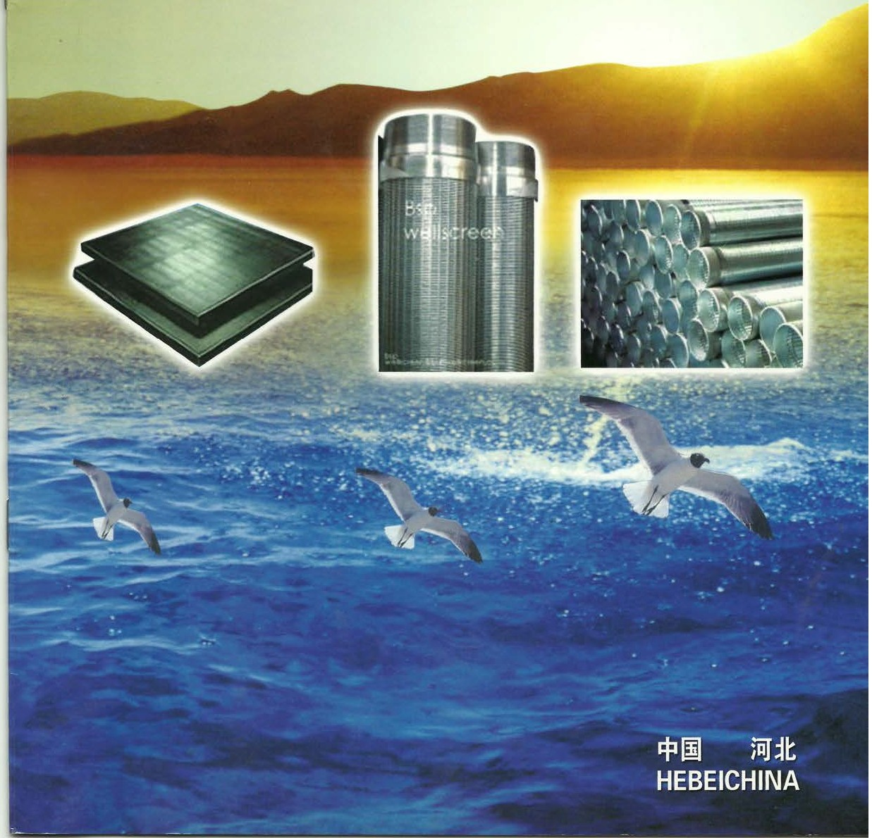

------------------------------------------------------....... .......



'

··· Sf.§ffi5JBi pxJ iM 1illtH 'ffi:·=F&-8 'ttjij]z·\.

jtS Sf.§, 0 * *.H*h . £A1i H*

1F:*.

ttpx] f"&> 1JOI 0o ftffl fflm'l'¥.-.t , .19l:• - ;g

l*Y!IJ , it,Fqitj £ftff1· :tif-Jlo :<$:0 1"vtt::f' WJ;Jtl}c, iiH Wl

;Jt*W- $••·•

r•pxj = ••·• .• •·•. WJpx], .

-pxJ.WJ pxJ, px].•%pxJ. Mjij],*

jij-]pfxJ"·&- I.!"

ffl rr#. * W.E.I .R.•

±fu , * m ;m. !fl:!f-&:!f-i¥1 :1ih &.

[Brief introduction]

-fi •o•!" moo

Anping county Hengyuan hardware netting industry product CO,.LTD. is located in Anping county reputation of ' Chinese hometown of wire mesh '. The company is equiped with advanced equipment and tremendous technical capability. It's a company which owns advanced technology and produces wire mesh and further processed products. For years, we have been sticking to the business principel of prestige thehighest quality-the first it's our highest standard to make the customers satisfied.Our company produce and sell as following :' V' shaped wire welded stainless steel screens, low carbon steel screens, Johnson Specialty screens,various kinds of

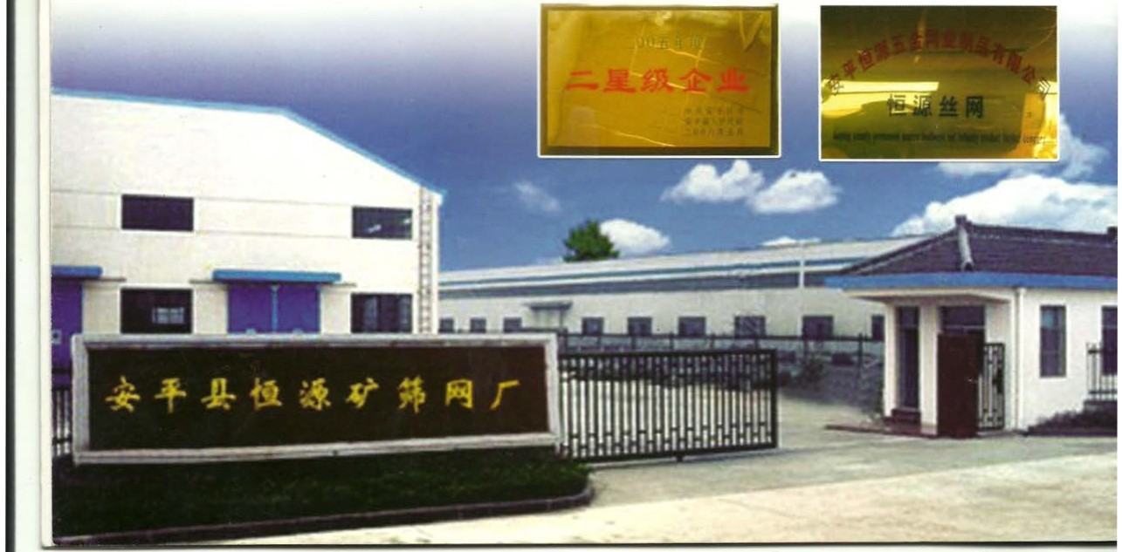

or escreen meshes , stainless steel networ k,chain link fence ,welded wire mesh, expanded plate mesh series,bringing type automatic filter screen, crimped wire mesh, hexaogonal wire mesh,etc. The products are used in the trades,such as ore choosing, petroleum . chemical industry , electron , transportation . plastics . food , architecture , traffic,etc. Our products can be seen everywhere in China,as well as African countries, Middle East and the regions of Southeast Asia.

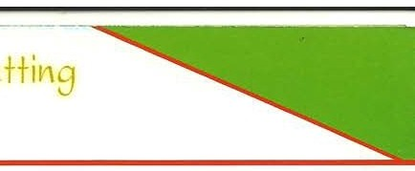

0'6]*F* Company products

jj:Strainers Pipe/ Water Well Screen

WI: 302. 304. 304L. 316. 316L 1' W.Itt

M•, 1' WJMM M••• * •* •- - * • tt • m•tt•a•tt·•*• MMtt (v ttl . *R m .* M•m . *.m.* m .m tt . m $*.

±CJtll,¢.\. CJ.ffi'f f'tlir"19HM:!.llt.

m•*••-f!tl n •*M. •#•.•*• • m. mT-* w&.•••- *

- I ffl*& ffl* * -- ** W. * W. M I*, tiMP -ii·& I

- M•.m m @ M.•

Mater ials, 304 302 304L 316 316L stainless steel wi r e

charact erist ics, The we l ded st ain less steel water well screen i s made up of rods and warp. The rod can be round w i re . tr iangular wire or tr apezo id wire. The war p is triangular wire (V-shaped wire). Water wel l screens have a st ructure and hig h open ar ea.as well as accurate slot dimension. I n t he same t ime water wel l screen have heat-resist ing, an t i-cor rosive, good machine capabili ty, long l if e span. safety and reliability and so on characterist ics . It can be used i n many k i nds of medium filtering .

Uses, The stra i ner is a kind of f i l t ered water tubing with the perforation . it can use with the deep well pump. dive t he wat er pump. a lso may use in the wa t er - t r eating equipment. the environmental protection. the sea wa t er transforms into the i ndustr i al water and l ife use water desalinat i on treatment. running wa t er treatment. water softening t r eatment . the petroleum industr y, The pet roleum product termi na l filters and the chemi cal aci d the alkali l iquid f i lters . the ethyl alcohol and so on the organic solut ion recycling fi l ters.

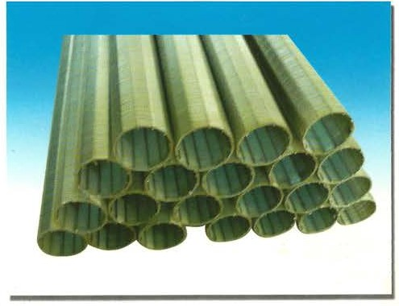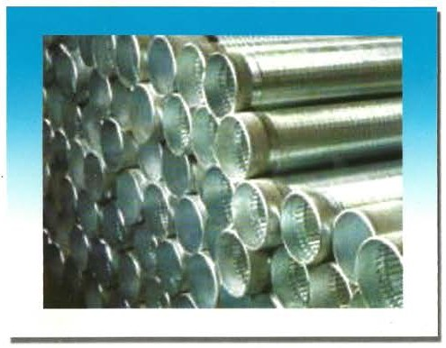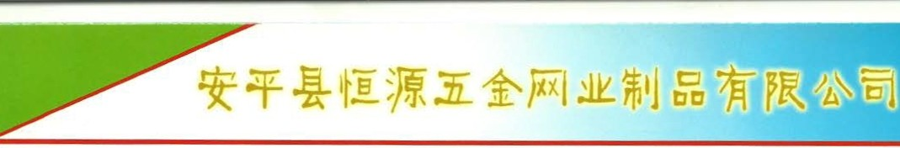

VID!f:f::'jq WJiml.l< 11 V 11shaped wire welded stainless steel screens

F 'tif!E

ftill0 v • •*• •*· •mv v &a !- &al tr• x

£ -tlilil.OX.

"V" shaped ladder-like stainless/carbon steel screen is a perfect combination of V-shaped wire

and V-shaped rod or round rod.The wire is welded onto the rod at each intersection point.

1 - :k:k 7d7]cW. l]cmtiM.

2 v uwr;s i!lt$E. fdO ;T,tJ(ijj .

3. - 1L JJ\flH Jt 1f1tffl.

4 •*•*•• . *n •.* R.

s •*•* ••&R.'ftm••*· ft . .ox* ·

Features of products

1 . A cont inuous slot opening which significantly increases the available open area, thus providing greater access to the water bearing zone.

2. A ·v· shaped profile wire which avoids clogging and ensures an uninterrupted flow.

3. A uniform and efficient well development due to the continuous slot opening.

4. Ladder-like wire welded screens have a strong structure and high open area,as well as accurate slot dimension.

5. Ladder-like wire welded screens have the features of easy backwashing,long life span.safety and reliability as well as low comprehensive cost.

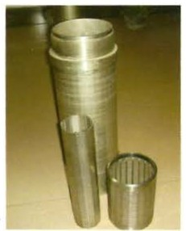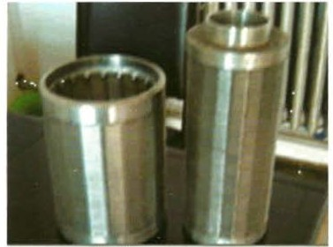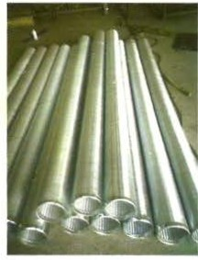

/" ,9:

1 n ••• •* Emm - • *· . #.

2 rr.OX*11f 1L Jl\$ -* 1ff1JT±t!f'f7}c A. Jt:jip l]cA'ft *U! U ;,IOC,J.' Milil

l.iOCYtiE.5iH'E.

3 M Alt!Ji f£1El a1ttl'. - tt-.J1L $1t ±t!!l'7]cf£ A·7]c flttt-.Jit-AI:t'ti1·

ftat llll'lt. JS :Y.ti!lt$Ei T-tr•* *ffl':ittA•*. 'J'*Jtaltiil.

4 m*•*•·# ··ffi ililS. ±t!!l'l]c AR - -7]cW8M- l]c;!,tJ.t. **# it

Features of products

1. Screens with high open area are more suitable for the construction of high-quality water wells.oil wells and gas wells.

2. Low cost operation Screens with high open *area* shall favor groundwater infiltration. Abundant water shall reduce the water level's down, thus to save energy consumption.

3. Reduce the,jibrasion of the pump Under the same condition.high ope1 area can make the speed of groundwater ' s entering into the screen much more slower than any other filtration apparatus.which will avoid sand ' s enter ing into screen because of high pressure,thus reduce the abrasion of the pump.

4. Extend the life span of wells Comparat ively,groundwater 's entering into screen with higher open area is

much easier than the entering into lower open area screen.The slow water flow shall extend the Iife span of wells.

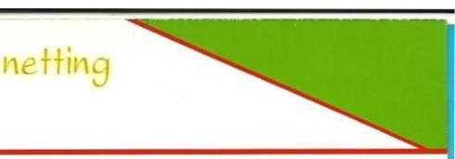

ty *He* g}_44AR **d a**

**ctCO.,LTD.**

;;t;: mBasic specification for ladder-like screen

|  |  |  |  |  |  |  |  |  |  |
| --- | --- | --- | --- | --- | --- | --- | --- | --- | --- |
| *M*  Material | -5-  SIZE  INCH | *9*  0.0 (MM) | !.ili!J!! SLOT INCH | *!.I  LENGH  (M) | DJ 3\':9 1J COLLAPSE STRENGTH  (PSI) | r,r$:1J TENSEI WEIGT (TON) | rt  1!.\:•ili  WRAP  (MM) | m :1-Hk  RODS (MM) | mY<JtE!i  End Connection |
| 304  304L  316  316L | 4 | 117 | 0.040 | 3-6 | 395 | 6 | 2 .2•3.0 | 3.8MM/22 | titO'lf Y-:  llli'l!fY-:  by welding ()( by tlveaded male/female ccx.plin. |
| 4 | 114.3 | 0.040 | 3-6 | 395 | 6 | 2.3•3. 0 | 3.8MM/22 |
| 6 | 168.3 | 0.040 | 3-6 | 252 | 8 | 2.3•3. 5 | 3.8MM/32 |
| 8 | 219.1 | 0. 010 | 3-6 | 399 | 10.5 | 3 .0•5.0 | 3.8MM/48 |
| 8 | 219.1 | 0. 020 | 3-6 | 370 | 10.5 | 3 .0•5.0 | 3.8MM/48 |
| 8 | 219.1 | 0.040 | 3-6 | 323 | 10.5 | 3.0•5.0 | 3.8MM/48 |
| 10 | 273.1 | 0.010 | 3-6 | 206 | 11 | 3 .0•5.0 | 3.8MM/50 |
| 10 | 273.1 | 0.020 | 3-6 | 191 | 11 | 3.0•5.0 | 3.8MM/50 |
| 10 | 273.1 | 0.040 | 3-6 | 167 | 11 | 3.0•5.0 | 3.8MM/50 |

flr)i , tl!liX. ftfnfiM&tl!l .Ptr-Jfl)j(f". 1i{,80mm- 900mmJ.Ul\: 0.1mm- 10mm The data only to reference.we can design it as the client ' s request Diameter ,80mm-900mm. Shot , 0.1mm-10mm

*J!f:iJ)Jt: f:i ttJ!f:i.

*f,j;ift*il: 50mm-5850mm

*Styles of connection,by welding or by threaded male/female couplin.

*Standard length: 50mm-5850mm

$L:/:t!X1l Crimped Mesh

*:!4: 302. 304. 304L. 316. 316L 1'mWJ . t!1CJW&tl!l .Ptr-J 5J(i.Ti.L

m&,m.m.rt m. tt m. mM. m. m .m tt.

m• • fi.

mB, m v. 6M. I.*&.H.

Materials , 304 302 304L 316 316L stainless steel wire ,can be made according to the customers ' requirement .

Weaving and characteristics : plain weave . twilled weave , dutch weave. stainless ssteel wire mesh is heat- resisting. acid- resisting. wear- resisting. corrosion- resisting .

Uscge: used in petroleum. chemical industry . mine. environment protection. food industry . medicine. machine making, etc.

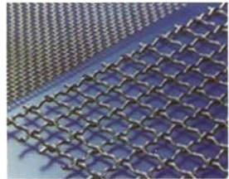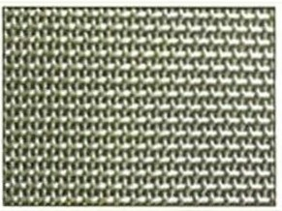

iP IX1l Chain link fence

m, m 0. tt; . *t.m.* tt !]'IZ.. 7tHHll. 11:9. 'fa.J. ti!& tr-Ji.Pt ll.M.P

M. M- tt .m·. M %Jt -- ••.••.--

!"& ,

General Use: Chain link fence mainly serves in protection of road. raiIway . airport. residence. port. garden

and farms.

Product characteristic : The anticorrosion. anti- exposes to the sun. Anti- aging characteristic and so on. The

anticorrosion form has the galvanization. the heat degree. spurts models. soaks models.

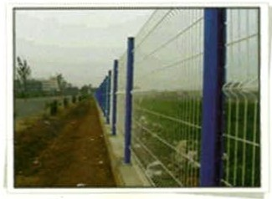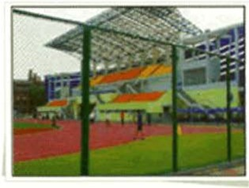

(/) **c**

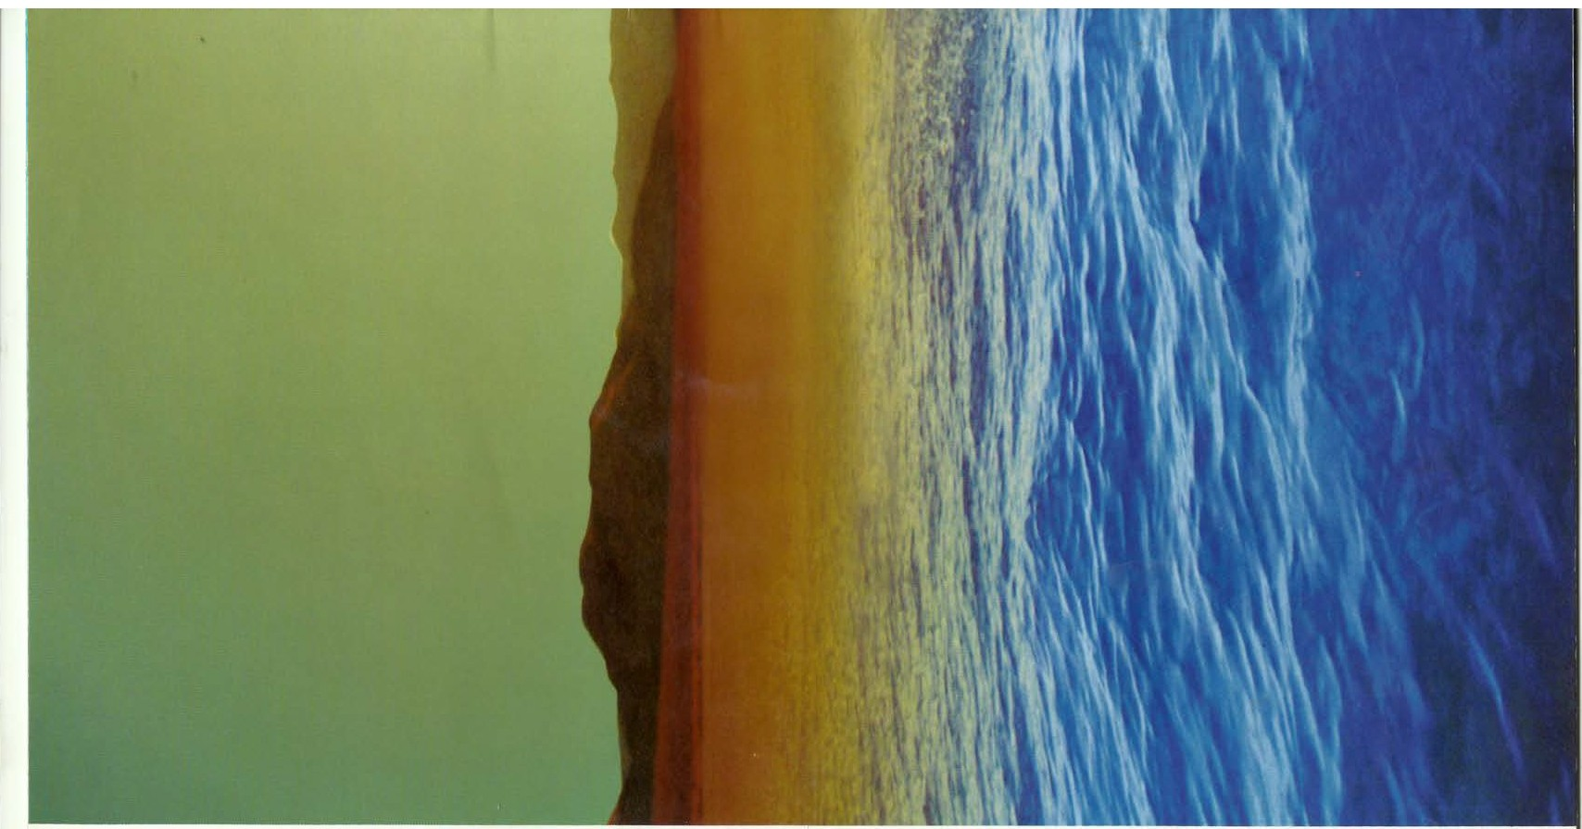

-**c._**)

(!) (/) **E** (!) **(1)0**

..... -

-

**O::o6 c** (/) Ol Q_

***·w***

**E**

(!) ::::l **Oo... ow(=L)**

<r:S

**tr)**

1,0

··=W *tE{ Bj-III)llll 1Dlli

Add: Industry Zone,Anping,hebeiProvince,China

.ffil!i;!t (Tel) · ·0086-0318-7565918

ltj-. (Mobile):llt-i!-l\\'1" ·13663281858

··13663281808

- (Fax)··0086-0318-7565919

-li !HgPc·.053600

E-mail: [l](mailto:liu@aphywirc.com)[iu@aphywirc.com](mailto:iu@aphywirc.com)

Website: [http://www.aphywire.com](http://www.aphywire.com/)



C) Quality Control

We have serious quality controlsystem, and have gain the 1509001:2000 Quality Certification



HEBEl HENGYUAN HARDWARE NETTING

INDUSTRY PRODUCTS CO.,LTD.



Ill"twfn •" C'd •nil l'l"l!t•lafd IIDI Il\tIhe loUo..-mquaht) tnaUS::I'tnnl •hllldllrd:

1509001: 2000

C t IU H U \ liOS< m••

0.."!\Jl{ll .utd l'nu .;h('fl M lllUhJdurm •rl ,\1..-Jlt ltltr f'l o'Jn 'fll.f- • h\..,

( loth l'lk t.; I >1" I tht!l'.uld nlhC'I lrutum..t hlk'r I I ncnl



CCIC CONFORMITY ASSESSIIE T SERVICES CO. LTO.



61 Page

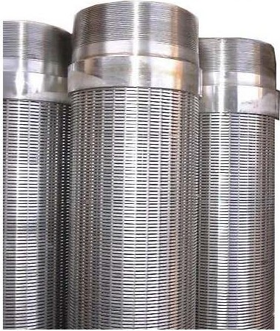

**Johnson Well Screen**

li Page

**A) Introduction**

**1. Materials: 304 302 304L 316 316L stainless steel wire**

Characteristics: The welded stainless steel water well screen is made up of rods and warp.The rod can be round wire. triangular wire or trapezoid wire. The warp is triangular wire (V-shaped wire).Water well screens have a structure and high open area,as well as accurate slot dimension.

At the same time, water well screen have heat- resisting, anti-corrosive, good machine capability, long time span, safety and reliability and so on. It can be used in many kinds of medium filtering.

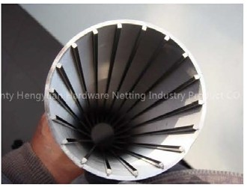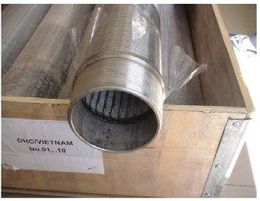

'V"shaped wire welded stainless steel screens

**2. Features of products**

1.A continuous slot opening which significantly increases the available open area, thus providing greater access to the water bearign zone.

2.A "v'' shaped profile wire which avoids clogging and ensures a uninterrupted flow.

3.A uniform and efficient well development due to the continuous slot opening.

4.Ladder-like wire welded screens have a strong structure and high open area.

5.Ladder-like wire welded screens have the features of easy backwashing ,long life span, safety and

reliability as well as low comprehensive cost.

21 Page

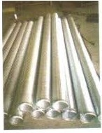

**3. Advantages of products**

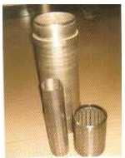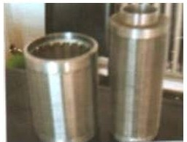

1 . Screens with high open area are more suitable for the construction of high quality water welis oil wells

and gas wells

2. Low cost operation Screens with hig1open area shall favor groundwater infiltration. Abundant water shall reduce the water level's down, thus to save energy consumption.

3. Reduce the abrasion of the pump urder the same condition, high open area can make the speed of groundwater's entering into the screen much slower than any other filtration apparatus, which will avoid sand's entering into screen because of 1igh pressure, thus reduce the abrasion of pump.

4. Extend the life span of welis comparatively; groundwater's entering into sereen with higher open area

is much easier than the entering into Iower open area screen. The slow water flow shall extend the life

span of wells.

**Effective open area for permanent Stainless Steel screen**

The permanent stainless steel screen is said to be 8 inch (2 00 mm) diameter with opening slot size= I mm. The percentage of open area for this standard sc:een is 25%.

|  |  |  |  |  |  |
| --- | --- | --- | --- | --- | --- |
| **1\Cn)inaiWP,II Str«-n Di:me:er** | **screen Slot Size** | | **Steel Continuous Slot PVC Continuous Slot** | | **PVC Slotted Pipe** |
| mm | No | **m m** | **m2/m** | % **tm?/m** 1/o | **cm2/m** _!i |
| 100 | *20* | **0,508** | 931 | *2* |  |
| 100 | 60 | **1.524** | 1.905 | 52 1.100 30 | 381 11 |
| ISO | 30 | 0.762 | 1,693 | 25 1.206 IS | 550 8 |
| ISO  **150** | 60  9; | **J .5211**  2.413 | 2,857  3,492 | 41 1,968 29  51 | 995 14 |
| 200  200 | 30  60 | 0.762  **LS24** | 1,629  i.ss7 | 16  28 |  |
| 200 | 95 | **2.413** | **3,851** | **38** |  |
| 100 | 115 | 3.175 | 4,529 | 45 |  |

li P age

The below equations was performed accordance with the equations presented in Growtd Water and Wells (Second Edition) by Principal Author Fletcher G. Driscoll (published by Johnson Filttation Systems Inc., St Paul, Minnesota 55112), page 451.

Effective PoenArea Calculation:



According to screen design and well design: Number of slot per each meter length of screen: *250*

Thickness of slots: Imm

Total Area OC slots per each meter OC screen pipe:

2x3.14x!Ox25 = 1570cm2

Surface area of one meter stainless steel slotted

Screen= 6280 cm2

LS%

i

.< *lO*

10:.,

."li

'C 10%

' s.

.. ·

c :.i%

<

·>

....

,

, .....

...

10 *1:.1*

slot size

*%o pen a·rea* -,-----.,-----.,...,..- X 100 slot size + wire width

bpected 1.\•ell ·ield, If sec

% *o p•n ar.a* =



1 . x 100 = 25%

1 2 9

+

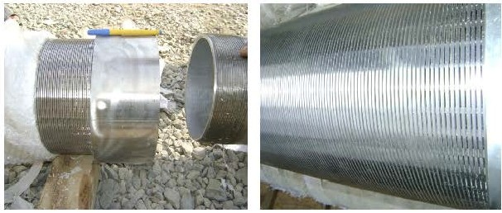

pie of joining two branch of screen

41 P age

**B) Basic Specification for Screens**

COLLAPSE TENSILE t

SIZE 0.0 SLOT LENGTH RAP ltl11ck"deepl RODS

STRENGTH WEIGHT

(INCH) (MM) (INCH) (M) (MM) (MM) (PSI) (TON)

4 117 0.040 3-6 395 6 2.2"3. 0 3.8MM/22

4 114.3 0. 040 3-6 395 6 2.3"3. 0 3.8MM/22

r-- -r-

6 168.3 0. 040 3-6 252 8 2.3"3. 5 3.8MM/32

t--

8 219.1 0. 010 3-6 399 10.5 3.0"5. 0 3.8MM/48

r--

8 219.1 0. 020 3-6 370 10.5 3.0"5. 0 3.8MM/48

--

8 219. 1 0. 040 3-6 323 10.5 3.0"5. 0 3.8MM/48

10 273.1 0.010 3-0 206 11 3.0"5.0 3.8MM/50

10 273.1 0.020 3-6 191 11 3.0"5.0 3.8MM/50

10 I 273.1 0.040 3-6 167 11 3. 0"5.0 3.8MM/50

The data for reference only and can design with client's request. Diamter:80mm-900mm, slot of screen size:0.1mm-10mm

Styles of connection: by welding or by threaded male /female coupling. Standard length: 50mm-5850mm

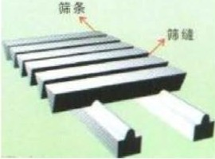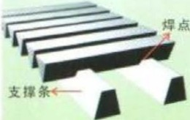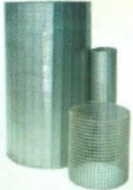

D) Detail Information for Johnson Stainless Steel pipes for Referenced

Task Order Well

Material type: Stainless Steel304

Nominal size:8 Inches

00:219.1 mm

Length: 2.0 and 4.0 meter

Slot Opening Size: 1.0 mm

7 1 Page

**KARAKAYA**



**Bentonit Sanayi ve Ticaret A. .**

Biiro :NecatibeyCad. Sezenler Sk No:1-12 Ankara Tel:(312) 2297626 Fax: (312) 2297872

Fabrika:Esenbo!ja yotu 24 Km Ankara Tel:(312) 3980145 Fax: (312) 3980146 http : [/lww](http://www.karakaya.com.tr/)w.[karakaya.com.tr](http://www.karakaya.com.tr/) e.mall :kkaya@ tr.net

**BENTONITE TEST CERTIFICATE**

DATE: 18/01/2010

1. DESCRIPTION OF SAMPLE : NON TREATED BENTONITE

GTiP :2508

ORIGIN

Re!?adiye c:x::J Any other



SAMPLED FROM

D D

Pit Stock Area Production

If Delivery , name :

Delivery D

2. EXPERIMENTS

A-) FILTRATE VOLUME ml

B-) VISCOSITY (Direct Indicating Viscometer)

Weight of Bentonite added in 350 ml distilled water, during preparation of suspension

22,5gr (%6,43) D 25gr(%7,15) [£]

a-)Dial reading at 600 r *I* min.



b-) Dial reading at 300 r *I* min.

C-) CALCULATION

a-) Plastic Viscosity PV =600 r *I* min - 300 r *I* min. ( 36

b-) Yield point (YP ) = 300 r *I* min -Pv ( 22

)-( 22 )=

) -(14 )=

c-) YP *I* PV Yield Point *I* Plastic viscosity ( 8 ) 1(14 ) =

EXPERIMENTIST COMMANDS

Biinyamin ERTEK Meets the Non treated Bentonjte Standards of ISO 13500 and

Mining Engineer. API 13 A Section 10.

|  |  |
| --- | --- |
| **Bentonite A.l'.l** | |
| Analysis report of Bentonite A.P.I | |
| Consentration | 22.5 gl350 cc |
| 600RPM | 30-32 |
| 300 RPM | 23-25 |
| PV | 7-9 |
| yp | 16-18 |
| YP/PV | 2-3 |
| Filter Loss | 15 **ml** Max. |
| Moisture | 10% WMax. |
| Residue on 200 Mesh Wet Screen | 1 %W |
|  | |
| **Bentonite O.C.M.A** | |
| Analysis report of Bentonite O.C.M.A | |
| Yeild Point | 20m3 *I T* |
| Filter Loss | 15 **ml** Max. |
| Moisture | 10% WMax. |
| Residue on 200 Mesh Wet Screen | 3%WMax |
| Residue on 200 Mesh Wet Screen | **1%** WMax. |
|  | |
| **Bentonite For Foundry** Uses | |
| Phisical Analysis report of Bentonite For Foundry Uses | |
| Montmoriloite | 70%Min . |
| Gellation Factor | 20%Min. |
| Swelling Factor | 30 **ml** *I* 2gr Min . |
| Gt·een Compresive Strengh | 4.5-5.5 grlcm2 |
| Sintering Point | 1100 c Min. |
|  | |
| **Bentonite F'or Pelletin** | |
| Phisical Analysis report of Bentonite For Pelleting | |
| Plat Test (Wet Absorbation) | 500-700% w |
| Moisture | 5%WMax. |
| Residue on 45 Mic. | 5 %WMax. |
| Iron Content (FeO) | 2%WMax. |
|  | |

**KARAKAYA Bentonit Sanayi ve Ticaret A. .**

CERTI FICATE OF ANALYSIS

Producer

Commodity

: Karakaya Bentonite Manufacture & Trade Co.

: Natural, non-treated Na- Bentonite

DESCRJPTJON

The natural bentonite, is pure, natural sodium based nontreated one, contains 90 % of Montmorillonite, has a high swelling capacity, confonns to API 13 A Section - 10 nontreated Benton ite ,TS EN ISO 13500 and TS 977 Type - 2 bentonite's specification. In water suspansion the natural bentonite is dispersed not flocculate. The product has the certificate of conformance to TS 977, given by Turkish Standards Institution.

Samples have been prepared according to the International Standards from the stocks at the premises of Karakaya Co.. Tests

have been carried out at the qual ity control laboratory of Karakaya Co. and the following results were obta ined.

|  |  |  |
| --- | --- | --- |
| Phvsical Proocrtics |  |  |
|  | API 13 A section 10 and TS EN ISO 13500 STANDARTS for NON-TREATED BENTONITE | TEST RESULTS |
| Moisture (%) | 12.5 max | 8 |
| SieveAnalysis *(* 200 mesh) | 4 max | 1,01 |
| Disperse Plastic V iscosity *(* P V) | 10min | 12,7 |
| Viscosity point  *(* Yield Point/plastic viscosity ) | 1,5 max | 0,4 |
| Disperse Filtration volume | 12.5 max | 11,8 |

|  |  |
| --- | --- |
| Chemical Analvis |  |
| Si02 | 61.28% |
| Ah03 | 17.79 % |
| Fe203 | 3,01% |
| CaO | 4,54% |
| Na20 | 2.70% |
| MgO | 2.10% |

K20

= 1.24%

Bunyamin ERTEK Mining Engineer